Week Beginning Monday 20th September 2021
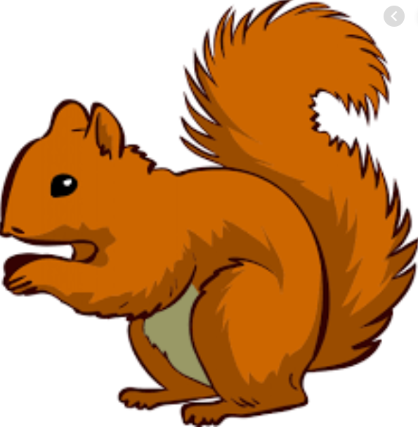
Year 1 Bulletin
Squirrel Class Staff: Mrs Atkinson and Mrs Fillingham - Class Teachers
Mrs Draper and Mrs McDonald - Teaching Assistants
Mrs Singh and Mrs Drummond - 1:1 Teaching Assistants
Fox Class Staff: Miss Clift – Class Teacher
Mrs Smith and Mrs Hurst – Teaching Assistants
Mrs Morris and Mrs Redfern - 1:1 Teaching Assistants
Support teacher- Mrs Leviss – Qualified Teacher, teaching across both classes.
Each week we will publish a bulletin that will give you information about what the children are learning at school, ideas for how to help at home, reminders and notes and any dates for the diary.
We are available before and after school if you would like to chat to us. You can either catch us outside or see Mrs Vallance or Mrs Lambert in the office who will make an appointment for you. We are really looking forward to working with you and your children this year. They have already made an amazing start!

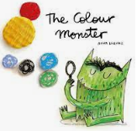
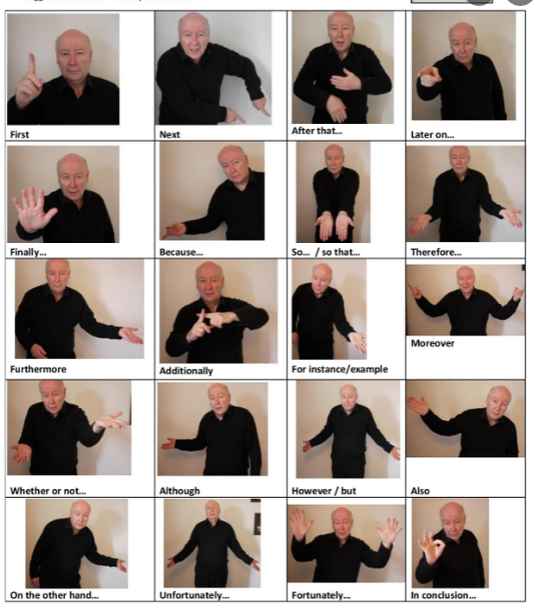
Topic – I am amazing!
English – “The colour monster”
This week we will continue to learn the story of “The Colour Monster”. This week we will be drawing a story map to help us learn it off by heart. We will begin to write the story using the story map.
Maths – Comparing weight, length, height, capacity and numbers
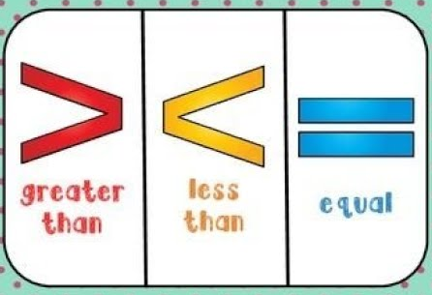
This week in maths we will be using comparative language to compare. We will be using language such as “greater than, less than, heavier, lighter, longer, taller, shorter and equal”. You could compare objects in your home and encourage the use of this language. We will also introduce these symbols:
Science- Using our senses
For the next few weeks we will be learning about our 5 senses.
Please let us know by Friday the 17th if you do not give your
Child permission to participate in a taste test. We will be trying- Ready salted hula hoops, cucumber, bread,
Raisins and lemons.

Reading
Reading books:
We have now assessed all children in year 1 and they will all be given a RWI reading book by the end of the week. They will also be given 1 or 2 books to share for some variety, however this may not match their reading level.
Other key information about reading:
* Your child will read in a group with an adult each day. This will not be recorded in the reading diary. We will also listen to your child 1:1 each week and this will be recorded in the reading diary.
* Your child’s books will be changed once a week. They will be given 2 or 3 new books.
* One of the books they bring home will be a Read Write Inc book. This is the level they are working at and the sounds in these books will be covered in their phonics sessions.
* The other two books will be books to share at home. We do not expect your child to read these books independently – they are books that are sent home for you to enjoy together and to expand the children’s reading diet.
* Please ensure books bags are brought into school each day. Reading records should be filled in for any reading done at home - this should be done three times per week.

Helping at home
* Please hear your child read at least 3 times a week and write in the reading record book.
* Read to your child – bedtime stories are the BEST!
* Practise counting sets of objects – ensuring they understand the numbers to 10 securely. Don’t be tempted to go too far.
Please Remember –
- Children come in PE kit on Tuesdays.
- They will need a bag of spare clothes to keep on their peg.
- Please make sure your child has a named water bottle in school.
- Please return any library books in their library folders.

Please don’t allow your child to being toys into school. These can be very easily lost and cause upset.

Many thanks for your support, The Year 1 Team

