Week Beginning Monday 1st November 2021
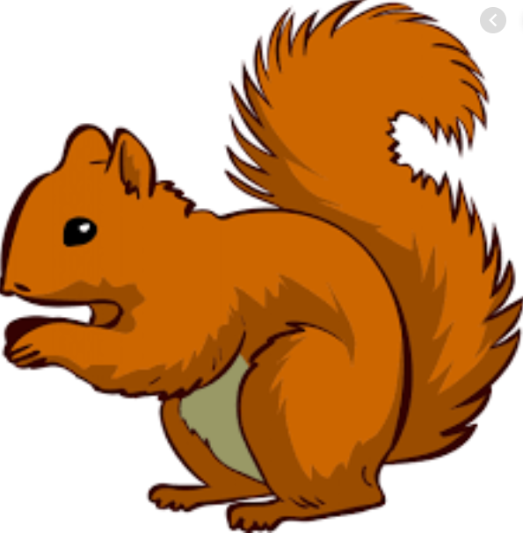
Year 1 Bulletin
Squirrel Class Staff: Mrs Atkinson and Mrs Fillingham - Class Teachers
Mrs Draper and Mrs McDonald - Teaching Assistants
Mrs Singh and Mrs Drummond - 1:1 Teaching Assistants
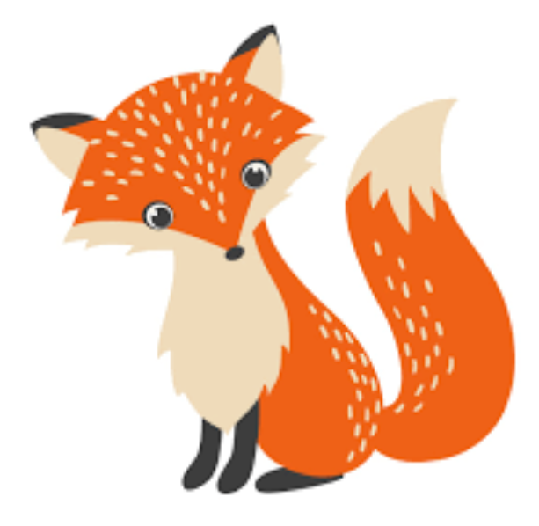
Fox Class Staff: Miss Clift – Class Teacher
Mrs Smith and Mrs Hurst – Teaching Assistants
Mrs O’Reilly and Mrs Dobson – 1:1 Teaching Assistants
Mrs Morris and Mrs Redfern - 1:1 Teaching Assistants
Support teacher- Mrs Leviss – Qualified Teacher, teaching across both classes.

Dear parents,
We hope you all had a lovely half term. We look forward to hearing all about your break! We have now finished
our “I am amazing” topic and will be moving onto “Toys and special times” for Autumn 2.

Topic – Toys and special times!
This half term, we will be learning about new and old toys in history and sharing stories about toys in English. We will be making toys in DT and visiting the Reading toy museum If you haven’t filled in the school trip form yet, please find this online and return it when we are back in school.
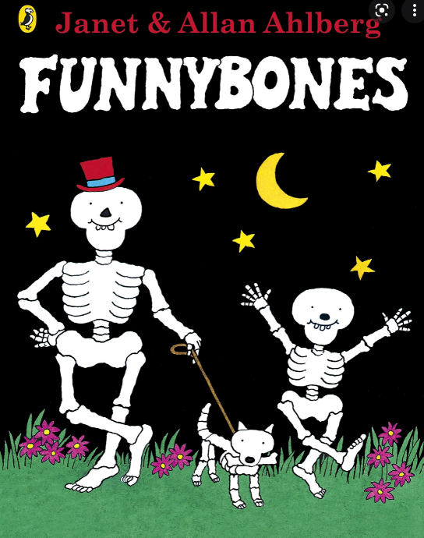
English – “Funny Bones”
We will be completing the story “Funny bones” in the first week back. We will be writing
the story as part of an assessment that we are planning on sharing with you for parents evening.

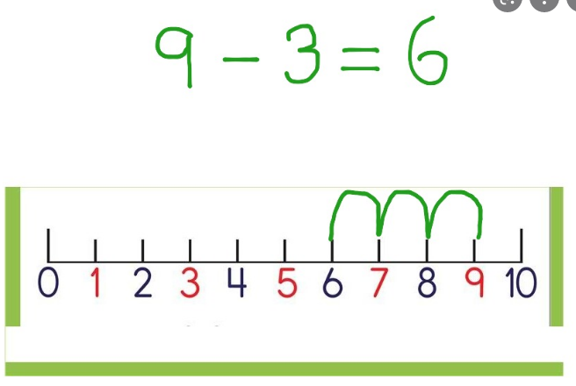
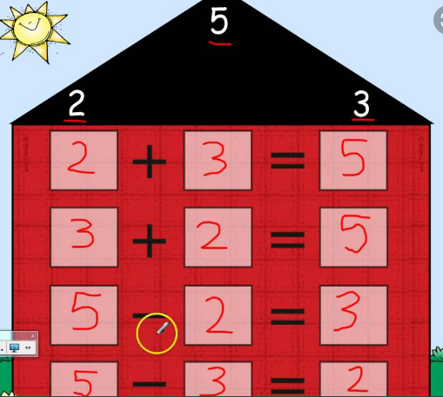
Maths – Subtraction
-Using the subtraction symbol
-Creating fact families -Finding a missing part
-Counting back on a number line

Phonics
We have finished the phonics assessments which may mean your child moves phonics group and reading level in the first week back at school.
Reading
*Your child will read in a group with an adult each day. This will not be recorded in the reading diary. We will also listen to your child 1:1 each week and this will be recorded in the reading diary.
* Your child’s books will be changed once a week. They will be given 2 or 3 new books.
* One of the books they bring home will be a Read Write Inc book. This is the level they are working at and the sounds in these books will be covered in their phonics sessions.
* The other two books will be books to share at home. We do not expect your child to read these books independently – they are books that are sent home for you to enjoy together and to expand the children’s reading diet.
* Please ensure books bags are brought into school each day. Reading records should be filled in for any reading done at home - this should be done three times per week.

Helping at home
* Please hear your child read at least 3 times a week and write in the reading record book.
* Read to your child – bedtime stories are the BEST!
* Practise counting sets of objects – ensuring they understand the numbers to 10 securely. Don’t be tempted to go too far.
Tuesday afternoon will be Celebration Assembly. This is an opportunity for your child to show or talk about any achievements or certificates/awards. If your child attends a club and has anything they would like to celebrate please send it in their book bag on a Tuesday morning.
Library day will be on a Wednesday for Squirrels and a Thursday for Foxes. If your child would like to change their book please ensure they bring their library folder and book to school on their library day.
Please Remember –
- Children come in PE kit on Tuesdays.
- They will need a bag of spare clothes to keep on their peg.
- Please make sure your child has a named water bottle in school.
- Please return any library books in their library folders.

Many thanks for your support, The Year 1 Team

