Week 7th September –11th September 2020
Bluebell Wood Bulletin

This week we have launched our topic ‘London’s Burning’. We will be finding out about London in the past and the present, the events of The Great Fire of London and what happened after the fire.

English
This week we have been reading the story ‘Norman the slug with the silly shell’ and learning actions to help us remember the story.
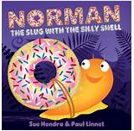

In the story we have been focusing on key words from the text and learning what they mean and how to read them. Please talk about these words at home.
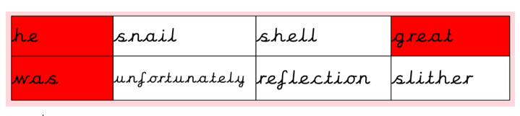
We have been recapping the features of a perfect sentence and have used capital letters, full stops, nouns, verbs, adjectives in our writing.
Activity: Please listen to your child read their school book or a book of their choosing at least three times a week. Please write in your child’s reading record every time you hear them read.

Maths
This week we have been focussing on place value and partitioning numbers into tens and ones using different apparatus.
We are continuing to order numbers up to 100 and making sure our numbers are formed correctly. We are also reading numbers in numerals and words.

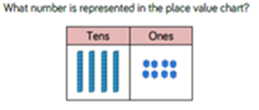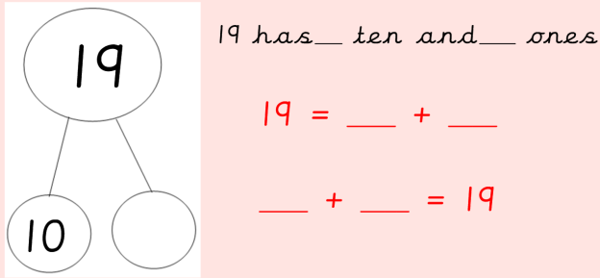

Reading:
Please use the Oxford Owl link below to login and access free e-books to read.
Look for the ‘My class login’ icon at the top of the page to login.
https://www.oxfordowl.co.uk/for-home/
Hedgehog class login details
My class name: hedgehogsjune
My class password: bluebell

Owl class login details
My class name: owlsjune
My class password: bluebell

Please Remember –
- At the moment children do not need to bring in a PE kit but they will need a bag of spare clothes to keep on their peg. We would appreciate it if this bag could include an art apron or old shirt.
- Please make sure your child has a named water bottle in school.
- Please have a look at our Topic Web for our topic ‘London’s Burning’.
- Look out for the fortnightly homework in the green folders in book bags this week.

