Week 12th October –16th October 2020
Year Two Class Bulletin

English

This week we went outside for an Autumn hunt to inspire us for our poetry that we are going to write. We are going to use our senses to describe what we can find in Autumn.
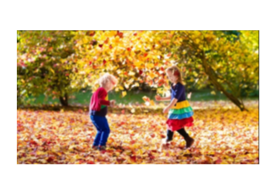

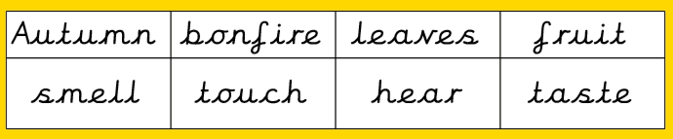

Activity: Please listen to your child read their school book or a book of their choosing at least three times a week. Please write in your child’s reading record every time you hear them read.

Maths

This week we have been looking at fact families and related facts. We have been using different apparatus to check if answers are true or flase.

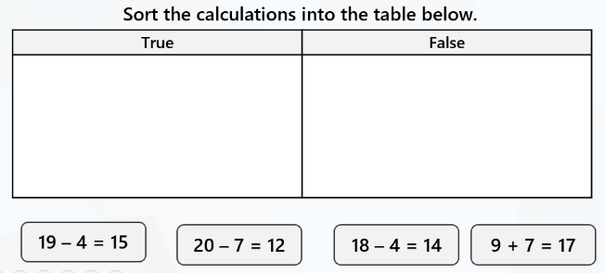
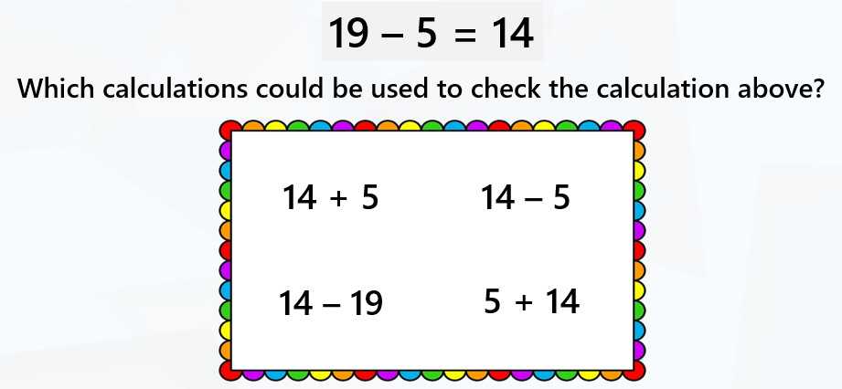

Reading:
Please use the Oxford Owl link below to login and access free e-books to read.
Look for the ‘My class login’ icon at the top of the page to login.
https://www.oxfordowl.co.uk/for-home/
Hedgehog class login details
My class name: hedgehogsjune
My class password: bluebell

Owl class login details
My class name: owlsjune
My class password: bluebell

Please Remember –
- School photos Wednesday 21st October.
- On Wednesday our Harvest Assembly will also be available on the website.
- As the weather is getting colder and more unpredictable, please could you make sure your child brings a coat to school.
- Fruit is provided for a snack in the morning. Children are welcome to bring in their own snack but please could you ensure that it is a fruit snack.
- Thursday the 22nd is ‘break the rules day’. Children can choose which rules they would like to break for 50p each. Please see last week’s parent mail for more detail.
- Friday the 23rd is an INSET day. The children return to school on Monday 2nd November.

