Week of the 13th June – 17th June 2022
Bluebell Wood Bulletin

Our Year Two Team:
Owl class – Mrs Lewis (Monday to Thursday) and Mrs Davies (Friday), Miss Brooks, Mrs Phillips and Mrs Patel.

Hedgehog class – Mrs Turner (Monday, Tuesday and Friday) and Mrs Davies (Wednesday and Thursday), Mrs Brooks, Mrs Kaushal and Mrs Patel.

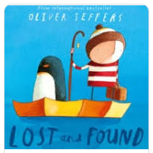
English:
This week we have been looking at our new text ‘Lost and Found’ by Oliver Jeffers. We have written a book review, found out lots about penguins in our research and written a fact file all about penguins.

Science:
In science we have been finding out about different habitats and what plants and animals are found in them. We went on a habitat walk in the school grounds and identified lots of different plants and even found a few brave creatures!

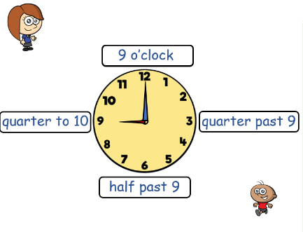
Maths:
This week in maths we have continued learning about time to 15 minutes. We have also recapped fractions 2/4 and ¾ of a shape and number.

Reading books:
Just to remind you that your child will have a set day to change their books. If they are on Read Write Inc (RWI) books they will take home one RWI book to read and two Oxford Reading Tree books to share. When an adult listens to your child read 1:1, it will be recorded in their reading record. Every child participates in a daily storybook lesson but this will not be recorded in their reading record.

Please ensure books bags are brought into school and reading records filled in for any reading done at home. Please listen to your child read at least three times a week.

If you, or anyone you know of, would be able to regularly volunteer to come in one afternoon and read with the children we would love to hear from you.

Please remember:
- Please make sure your child has a named water bottle in school.

- Please remember to make sure your child is wearing sun cream and brings a named hat to school.

- Year Two PE days are Monday and Wednesday. Please can your child come into school wearing the Willow Bank PE kit.

- Sports day is Thursday 23rd June. They will need to come to school in their PE kit and coloured t-shirt. Your child will have had a slip sent home today as to what colour t-shirt they will need to wear. Please check your child’s book bag. Children should be dropped off at normal time and will be brought to the junior field at 9:15.

