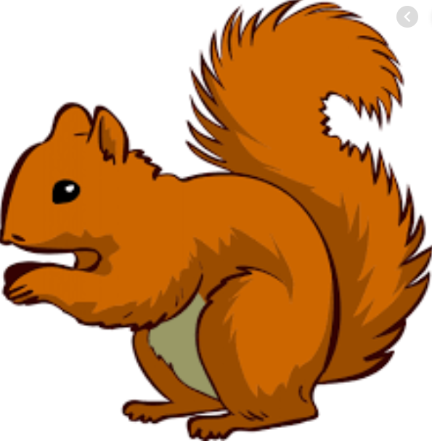
Week Beginning Monday 5th September 2020
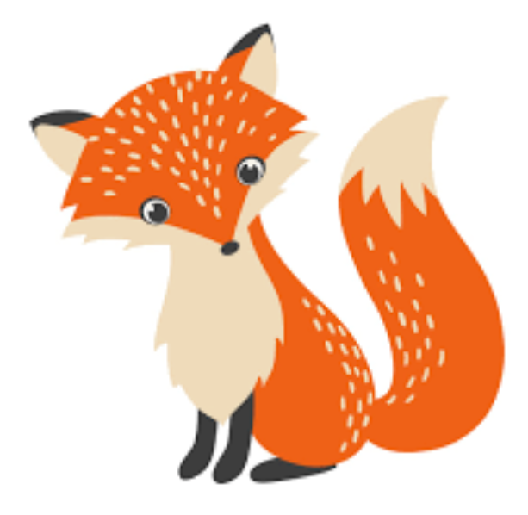
Topic – I am amazing!

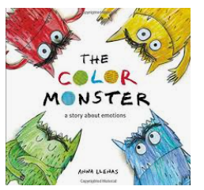
English – The Colour Monster
We are getting to know the story called The Colour Monster. It is a delightful story that is helping all the children think about how all our emotions feel. Over the next two weeks we will be continuing to learn it and turning it into a poem of our own!
Maths – Number bonds to 10
* What two numbers can be added together to make 10?
*Write the number sentence to represent number bonds.
*Are there any more ways to make 10?
* Can you see a pattern in these numbers?

Reading
We have loved exploring different stories since coming back to school. We have had some children who have come back and got out of practice with their reading. We completely understand they are a little frustrated as they may have forgotten how to use some of their phonics. We are running daily phonics sessions to help support this. Any reading is good reading so even if they are using a tablet to read an Ebook or a magazine of their interest that is a positive!
Please hear your child read their reading book at least 4 times a week and write in their reading record. This will allow them to learn the words in the book and enjoy the story too! We can then change your child’s reading book and help them enjoy more and more different stories each week.
Maths
The children have loved counting games and Maths activities at school. Counting and writing digits 0-20 is very important and can be practised in lots of different ways.
To help them at home, you could play games and get them to write the scores; they could go with an adult to the shops and write down prices to see how numbers are formed; they could even count dishes in the kitchen cupboard to help with a family task!

Other ways to help at home
* Read to your child – bedtime stories are the BEST!
* Ask your child questions like “What was your favourite part of the story?” “Who was your favourite character?” for non fiction “Why do you think the book has this title?” “What do you think it will be about?” “What information does it give us?”
Key question- How many ways can we write addition to 10? (1 + 9 = 10, 9+1 = 10, 2 + 8 = 10, 8+2= 10…)
Donations
We would be really grateful for any of the following donations. We have already had some in and the children have loved using them all!
*Cotton Buds *Golf tees *Rice *Dry noodles *Flour *Oats *Lentils *Junk modelling
These will greatly enhance our provision for the children. Many thanks in advance.
Many thanks Miss Clift, Mrs Atkinson and Mrs Fillingham

