Week 5th October –9th October 2020
Year Two Class Bulletin

English
We have been practising writing a letter from Vlad the flea to King Charles the Second. To help us remember, we thought of different actions for each part of the letter.

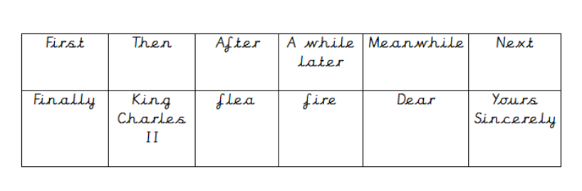
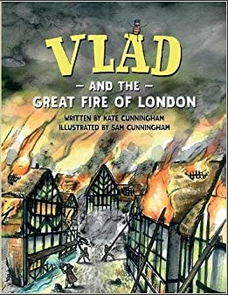

Activity: Please listen to your child read their school book or a book of their choosing at least three times a week. Please write in your child’s reading record every time you hear them read.

Maths

This week we have been looking at fact families and related facts. We have been continuing to use our symbols < > = to compare different calculations. For our jumpstart we have been counting in threes.

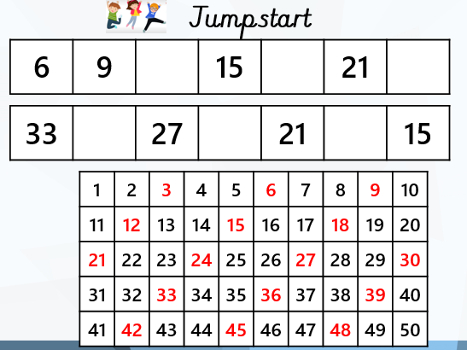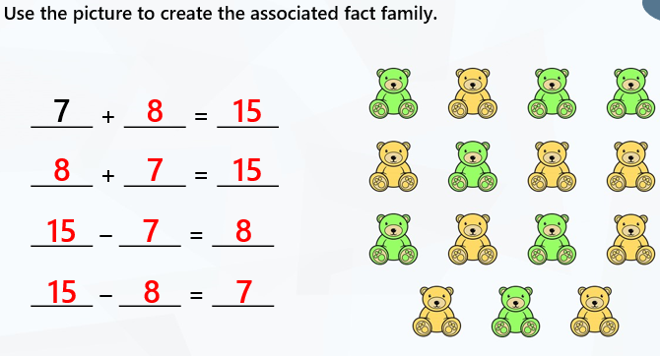

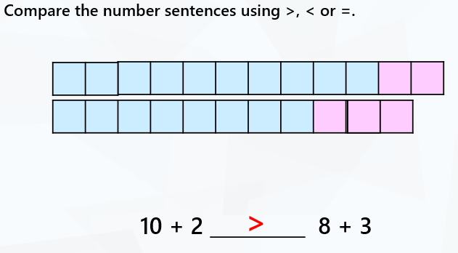

Reading:
Please use the Oxford Owl link below to login and access free e-books to read.
Look for the ‘My class login’ icon at the top of the page to login.
https://www.oxfordowl.co.uk/for-home/
Hedgehog class login details
My class name: hedgehogsjune
My class password: bluebell

Owl class login details
My class name: owlsjune
My class password: bluebell

Please Remember –
- Children will have a Christmas card design in their bags this week. If you would like to place an order the leaflet on the back explains how. Online orders are open until the 20th October. The original artwork needs to come back to back to school so it can be scanned.
- Please could you bring in any pictures you have of fruits and vegetables. We are planning some harvest art. Thank you.

