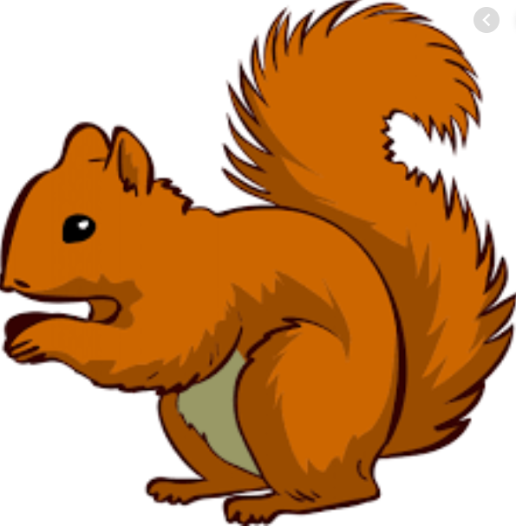
Week Beginning Monday 14th September 2020
Topic – I am amazing!

English –
The Little Red Hen
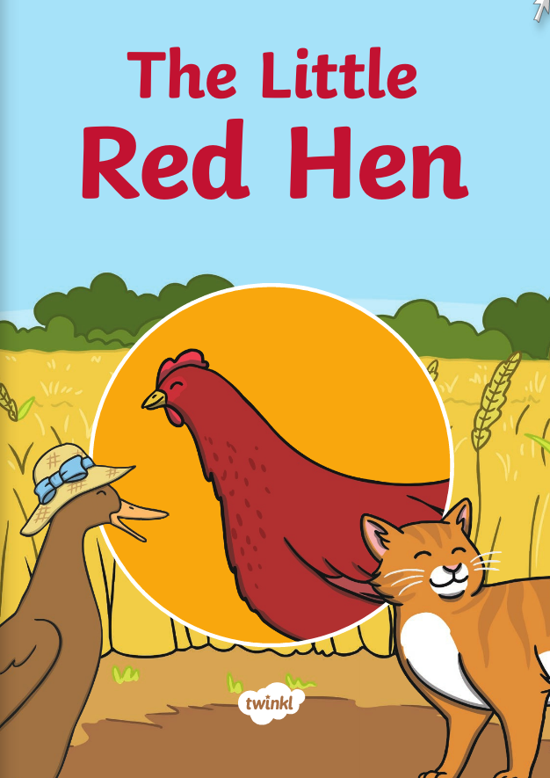
We will be continuing to do activities around this story. Children are learning this off by heart. You could ask them to see if they can recite it to you.
Maths - Counting
* Counting forwards and backwards within 20
* Comparing numbers
* Recognising more than and less than symbols
* Forming the numbers correctly.

Helping at home
* Please hear your child read at least 4 times a week and write in the reading record book.
* Read to your child – bedtime stories are the BEST!
* Practise counting sets of objects – ensuring they understand the numbers to 20 securely. Don’t be tempted to go too far.
Key question- How can we make 14? (10+4= )

Please Remember –
- At the moment children do not need to bring in a PE kit but they will need a bag of spare clothes to keep on their peg. We would appreciate it if this bag could include an art apron or old shirt as we cannot share aprons at present.
- Please make sure your child has a named water bottle in school.
- Please return any library books in their library folders.

Reminders
* By next Thursday 17th Sept at the latest: Please can your child bring in a photograph or a drawn picture that shows something they belong too. This could be a club, a team, or even a family.

Many thanks Miss Clift, Mrs Atkinson and Mrs Fillingham

