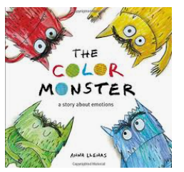
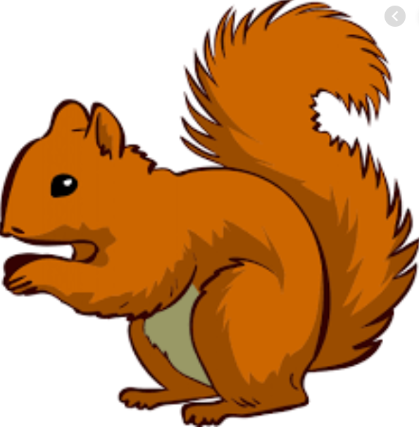
Week Beginning Monday 12th September 2020
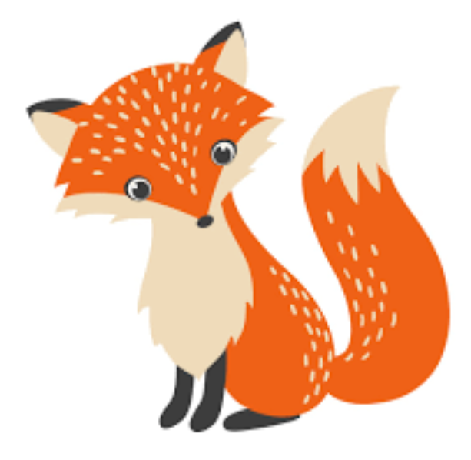
Topic – I am amazing!
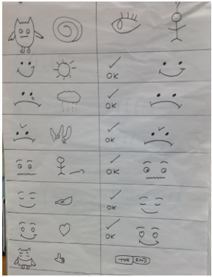
English – The Colour Monster
We are learning to retell the story of “The Colour Monster”. You could ask your child to retell it to you, using this story map. This week we will be having a go at changing the story and writing our own versions.

Maths – Addition
* Adding 2 numbers to find the total
* Using the less than, greater than and equal to signs < = >
* Count on using a number line
* To show addition on a tens frame and a whole part model

Maths
The children have loved counting games and Maths activities at school. Counting and writing digits 0-20 is very important and can be practised in lots of different ways.
To help them at home, you could play games and get them to write the scores; they could go with an adult to the shops and write down prices to see how numbers are formed; they could even count dishes in the kitchen cupboard to help with a family task!

PSHE
This week’s focus is using “Emerald” power (perseverance, not giving up). Please have a chat with your children about what it means to show perseverance and talk about even when it gets hard to not give up. There is no such thing as can’t... “you can’t do it yet” .

Other ways to help at home
* Read to your child – bedtime stories are the BEST!
* Ask your child questions like “What was your favourite part of the story?” “Who was your favourite character?” for non fiction “Why do you think the book has this title?” “What do you think it will be about?” “What information does it give us?”
Key question- How many ways can we write addition to 10? (1 + 9 = 10, 9+1 = 10, 2 + 8 = 10, 8+2= 10…)
Donations
We would be really grateful for any of the following donations. We have already had some in and the children have loved using them all!
*Cotton Buds *Golf tees *Rice *Dry noodles *Flour *Oats *Lentils *Junk modelling
These will greatly enhance our provision for the children. Many thanks in advance.
Many thanks Miss Clift, Mrs Atkinson and Mrs Fillingham

