Week 19th October –22nd October 2020
Year Two Class Bulletin

Welcome to half term! It has been a very busy eight week and the children have all been brilliant. We hope you all have an enjoyable and relaxing week.

If you haven’t seen it already the Harvest Assembly videos are on the school website. You can find them under the gallery tab. We hope you enjoy them!

English

This week we have written our Autumn poems using our senses. We were choosing exciting adjectives to describe features of Autumn and remembering our commas in a list.
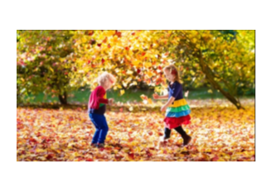

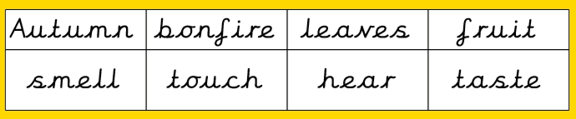

Activity: Please listen to your child read their school book or a book of their choosing at least three times a week. Please write in your child’s reading record every time you hear them read.

Maths

This week we have been adding and subtracting 10 and 20 from different numbers using a number square and diennes.

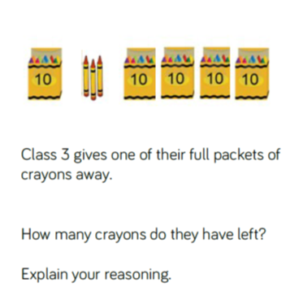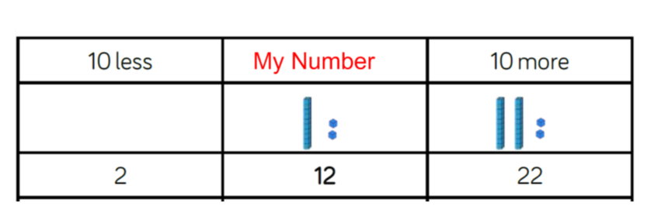

Reading:
Please use the Oxford Owl link below to login and access free e-books to read.
Look for the ‘My class login’ icon at the top of the page to login.
https://www.oxfordowl.co.uk/for-home/
Hedgehog class login details
My class name: hedgehogsjune
My class password: bluebell

Owl class login details
My class name: owlsjune
My class password: bluebell

Please Remember –
- Children are back at school Monday 2nd November.
- We haven’t set any homework for half term so don’t worry if you can’t find it in the book bags!

