Week of the 27th – 1st October 2021
Bluebell Wood Bulletin

Our Year Two Team:
Owl class – Mrs Lewis (Monday to Thursday) and Mrs Davies (Friday), Mrs Holtham, Mrs Sidhu and Mrs Patel.

Hedgehog class – Mrs Turner (Monday, Tuesday and Friday) and Mrs Davies (Wednesday and Thursday), Mrs Brooks, Mrs Kaushal and Mrs Patel.

Our Learning:
English:
This week we have been using ‘Talk for Writing’ to retell and write the story ‘Norman the Slug with the Silly Shell’
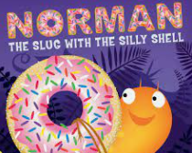

These are the speed words we have been learning from the book. Please talk about them with your child and spot them in the books you read together.

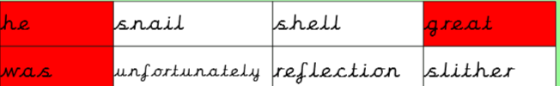

Maths:
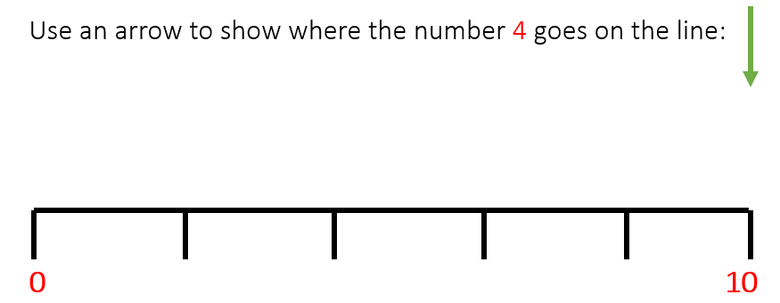
We have been counting in 2s, 5s and 10s and placing numbers on an empty number line.

Music:
We are learning about pitch and have been learning and listening to high and low sounds. We used Xylophones to make high and low pitch sounds.
In singing assembly, we have been learning one of our harvest songs ‘Cauliflowers Fluffy’ and ‘Thank you for my friend’ which we will be singing as part of our Friendship day on Monday.

History and Geography:
We have been finding out how the Great Fire of London started and why it spread so quickly.

Science:
We have been comparing the suitability of different materials for different uses. We have thought about the properties of materials and selected the most suitable material to do a job.

ICT:
We have been discussing how information technology is used in different environments.

RE:
This week we are starting to think about harvest. We have been looking at the Jewish festival of Sukkot and how it is celebrated.

Half Termly homework:
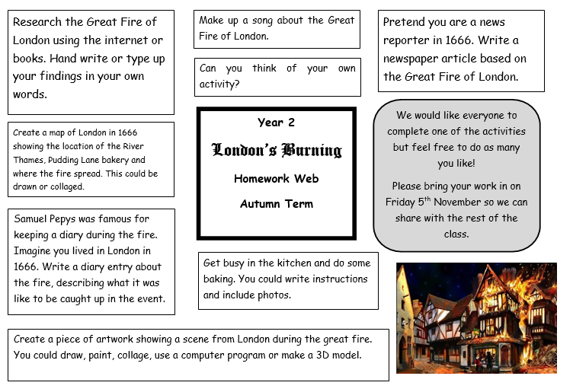

We are really enjoying finding out about the Great Fire of London and would love to see what you can find out at home as well. Please look at the homework sheet (above or on the website) and bring in your learning on the 5th November.

Reading books:
Just to remind you that your child will have a set day that they are listened to read and are able to change their books. If they are on Read Write Inc (RWI) books they will take home one RWI book to read and two Oxford Reading Tree books to share. When an adult listens to your child read 1:1, it will be recorded in their reading record. Every child participates in a daily storybook lesson but this will not be recorded in their reading record.

Please ensure books bags are brought into school and reading records filled in for any reading done at home. Please listen to your child read at least three times a week.

If you, or anyone you know of, would be able to regularly volunteer to come in one afternoon and read with the children we would love to hear from you.

Please remember:
- Please make sure your child has a named water bottle in school.
- Year Two PE days are Monday and Wednesday. Please can your child come into school wearing the Willow Bank PE kit.
- If your child has received a certificate or award from outside of school we would love to see them and celebrate at school. These can be brought in on a Friday.
- We will be making Tudor houses in DT this term and we need as many boxes as possible! We need donations of large cereal boxes and shoe boxes. Many thanks.

