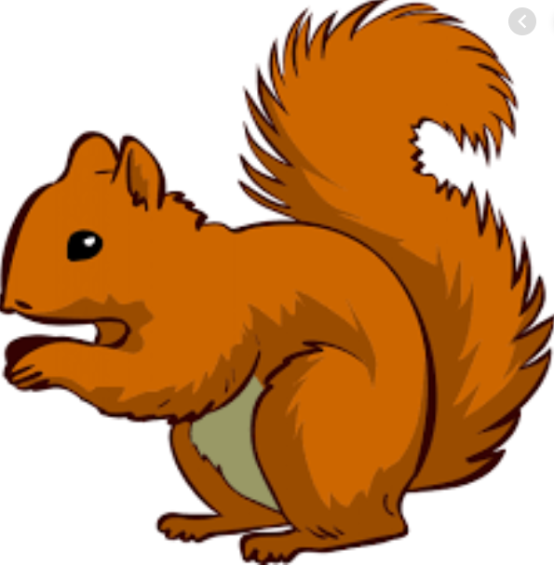
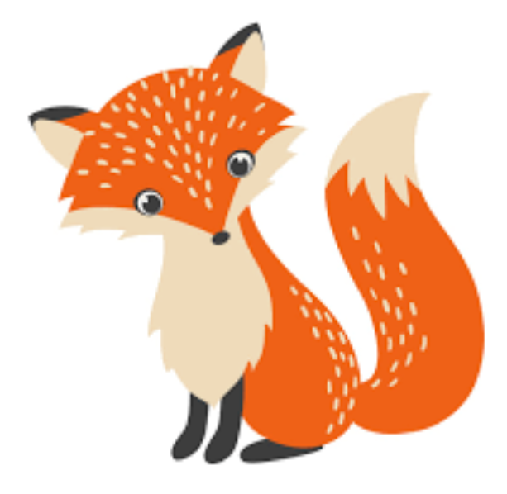
Week Beginning Wednesday 24th January 2022
Year 1 Bulletin
Squirrel Class Staff:
Mrs Atkinson and Mrs Fillingham - Class Teachers
Mrs Draper and Mrs McDonald - Teaching Assistants
Mrs Singh and Mrs Drummond - 1:1 Teaching Assistants
Support teacher- Mrs Leviss – Qualified Teacher, teaching across both classes

Fox Class Staff:
Miss Clift – Class Teacher
Mrs Smith and Mrs Hurst – Teaching Assistants
Mrs O’Reilly and Mrs Dobson – 1:1 Teaching Assistants
Mrs Morris and Mrs Redfern - 1:1 Teaching Assistants

.

Microsoft Teams
We are now uploading our learning onto Teams for children who are isolating at home due to Covid-19. We will be uploading the learning the night before the lessons are due to be taught at school. Please refer the Timetable for the week which you can find on our website with this newsletter or on Teams. We are aware that everyone’s situations will be different and Covid-19 continues to be prove challenging. Therefore, children can have a week to submit learning online (so they do not have to do it on the exact day it is set) to allow for differences in circumstance and situations. Children do not have to submit learning if they are unwell.

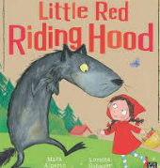
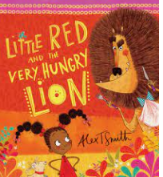
English
In English we will be reading and learning the story of “Little Red Riding Hood” and comparing it with the story of “Little Red and the Very Hungry Lion”.
We will be answering questions and writing using adjectives and different punctuation. In your child’s reading books, you could look for examples of full stops, question marks and exclamation marks to think about why different punctuation is used.

Maths
In Maths this week we will be-

Continuing to learn about subtraction crossing 10, related addition and subtraction facts and comparing number sentences.

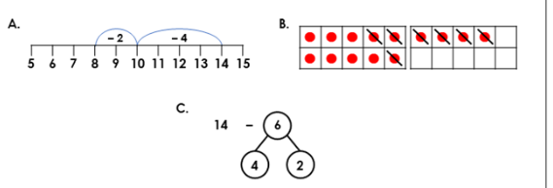
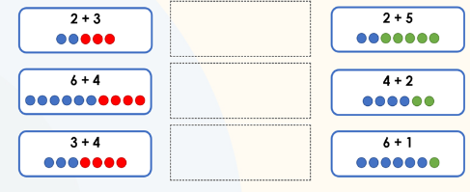

Reading
*Your child will read in a group with an adult each day. This will not be recorded in the reading diary. We will also listen to your child 1:1 each week and this will be recorded in the reading diary.
* Your child’s books will be changed once a week. They will be given 2 or 3 new books.
* One of the books they bring home will be a Read Write Inc book. This is the level they are working at and the sounds in these books will be covered in their phonics sessions.
* The other two books will be books to share at home. We do not expect your child to read these books independently – they are books that are sent home for you to enjoy together and to expand the children’s reading diet.
* Please ensure books bags are brought into school each day. Reading records should be filled in for any reading done at home - this should be done three times per week.
Helping at home
* Please hear your child read at least 3 times a week and write in the reading record book.
* Read to your child – bedtime stories are the BEST!
* Practise counting sets of objects – ensuring they understand the numbers to 10 securely. Don’t be tempted to go too far. 7

The children in year 1 now all have logins for purple mash. Please log into your child’s account and have an explore of the games and activities available to use. You will find their log in details in their reading record book.
https://2simple.com/purple-mash/

Please Remember –
- Children come in PE kit on Tuesdays and Thursdays.
- They will need a bag of spare clothes to keep on their peg.
- Please make sure your child has a named water bottle in school.
- Please return any library books in their library folders.

Many thanks for your support, The Year 1 Team

