Week 21st September –25th September 2020
Bluebell Wood Bulletin

Topic:
This week we have been finding out more about the Great Fire of London and the sequence of events. We have looked at how it started and why it spread so fast.

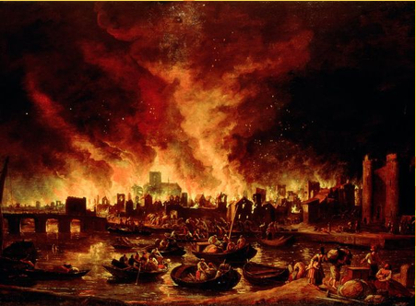

English
This week we have innovated the story ‘Norman the slug with the silly shell’ and created our own minibeast character with a silly shell.

Activity: Please listen to your child read their school book or a book of their choosing at least three times a week. Please write in your child’s reading record every time you hear them read.

Maths
We have been comparing and ordering numbers up to 100 and we have started to count in 2s, 5s, and 10s. We are continuing to make sure our numbers are formed correctly as well as reading and writing numbers in numerals and words.

Reading:
Please use the Oxford Owl link below to login and access free e-books to read.
Look for the ‘My class login’ icon at the top of the page to login.
https://www.oxfordowl.co.uk/for-home/
Hedgehog class login details
My class name: hedgehogsjune
My class password: bluebell

Owl class login details
My class name: owlsjune
My class password: bluebell

Please Remember –
- As part of our topic ‘London’s burning’ we will be making Tudor Houses. We would be grateful if you could bring in a shoebox or cereal box so they can make their DT project. Thank you for all the boxes you have brought in so far.

