Week of the 4th – 8th October 2021
Bluebell Wood Bulletin

Our Year Two Team:
Owl class – Mrs Lewis (Monday to Thursday) and Mrs Davies (Friday), Mrs Holtham, Mrs Sidhu and Mrs Patel.

Hedgehog class – Mrs Turner (Monday, Tuesday and Friday) and Mrs Davies (Wednesday and Thursday), Mrs Brooks, Mrs Kaushal and Mrs Patel.

Our Learning:
English:
This week we have started to plan and write our own version of ‘Norman the Slug with the silly shell’.
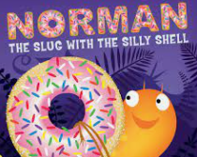

Next week we will have be editing our work.

Maths:
This week we have started our addition and subtraction unit and have been looking at fact families, related facts and checking calcuations.

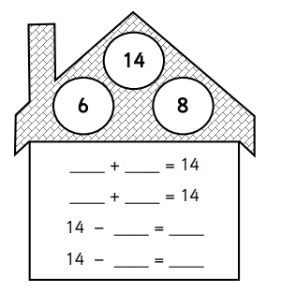
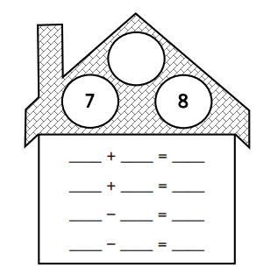

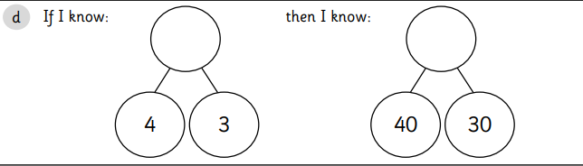

Music:
We are continuing to learn about pitch and have been creating our own pitch lines and using our voices to follow them.

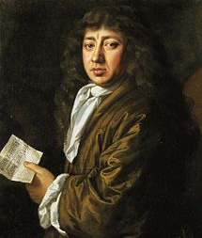
History and Geography:
We have thinking about how we know about the Great Fire of London and eye witnesses. We found out more about Samuel Pepys and why he was an important figure in 1666.

ICT:
We have been discussing how we can keep safe online and how to use information technology responsibly.

RE:
We have continued to find out about the Jewish festival of Sukkot and worked together to create our own Sukkah.

PSHE:
This week we celebrated Friendship Day. We talked about being a good friend in assembly, shared books and did activities in our classroom. Next week we will be thinking about and talking about Rosa Parkes as part of Black History month.

Reading books:
Just to remind you that your child will have a set day that they are listened to read and are able to change their books. If they are on Read Write Inc (RWI) books they will take home one RWI book to read and two Oxford Reading Tree books to share. When an adult listens to your child read 1:1, it will be recorded in their reading record. Every child participates in a daily storybook lesson but this will not be recorded in their reading record.

Please ensure books bags are brought into school and reading records filled in for any reading done at home. Please listen to your child read at least three times a week.

If you, or anyone you know of, would be able to regularly volunteer to come in one afternoon and read with the children we would love to hear from you.

Please remember:
- Please make sure your child has a named water bottle in school.
- Year Two PE days are Monday and Wednesday. Please can your child come into school wearing the Willow Bank PE kit.
- If your child has received a certificate or award from outside of school we would love to see them and celebrate at school. These can be brought in on a Friday.
- Monday 11th October the school photographer is coming in to take individual school photos. Please can the children come in their school uniforms.
- Thursday 14th October. Please can the children come in their PE kits. A cricket coach is coming in to do a session with the children.

