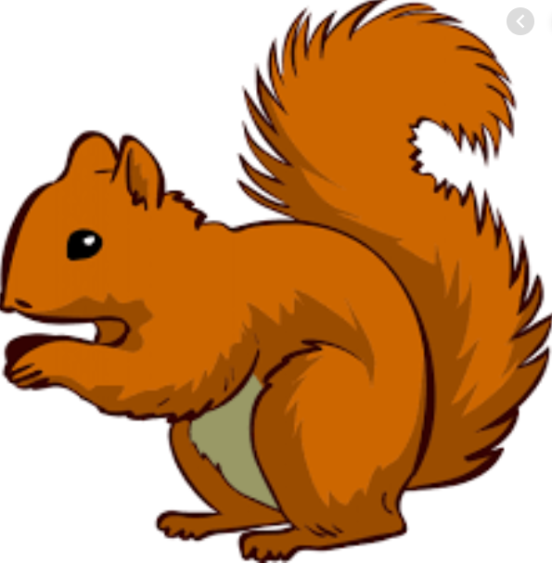
Week Beginning Monday 21st September 2020
Topic – I am amazing!

English –
The Little Red Hen
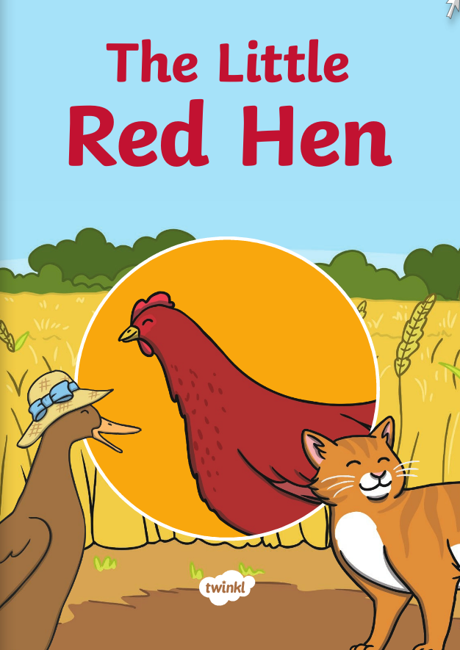
We will be continuing to do activities around this story. Children will be creating their own versions of the story this week.
Maths - Comparing numbers
* Counting out objects and amounts
*Using the greater than, less than and equal to sign < > =
*Number formation practise
*Reading and writing numbers

PSHE
The children are really glad to be back at school and happy to see their friends. During our circle times we have been discussing our gem power. This week’s focus has been on “ruby” power (kind, friendly, supportive and helpful). Please have a chat with your children on what kindness means and how they can be kind to others.

Helping at home
* Please hear your child read at least 4 times a week and write in the reading record book.
* Read to your child – bedtime stories are the BEST!
* Practise counting sets of objects – ensuring they understand the numbers to 20 securely. Don’t be tempted to go too far.
Key question- How can we make 16? (10+6= )

Donations
We would be really grateful for any of the following donations-
*Penne Pasta
*Cotton Buds
*Golf tees
*Rice
*Dry noodles
*Flour
*Oats
*Lentils
*Junk modelling
These will greatly enhance our provision for the children. Many thanks in advance.
Many thanks Miss Clift, Mrs Atkinson and Mrs Fillingham

