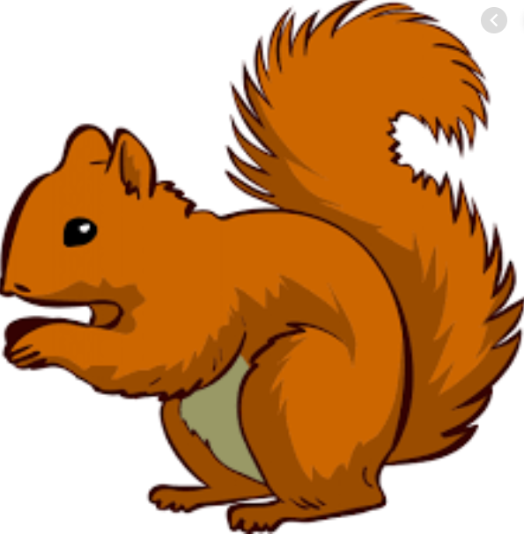
Week Beginning Monday 23rd May 2022
Year 1 Bulletin
Fox Class Staff:
Miss Clift – Class Teacher
Mrs Smith and Mrs Hurst – Teaching Assistants
Mrs O’Reilly and Mrs Dobson – 1:1 Teaching Assistants

Squirrel Class Staff:
Mrs Atkinson - Class Teacher
Mrs Draper and Mrs McDonald - Teaching Assistants
Mrs Singh and Mrs Drummond - 1:1 Teaching Assistants
Support teacher- Mrs Leviss – Qualified Teacher, teaching across both classes

.

Dates for the Diary-
WC Monday 23rd – Woodley Sports Week. Please drop children off at 9am at Woodford Park Leisure Centre for a prompt 9.15 start (details to follow in a separate whole school letter).
27th – last day of Summer 1 term

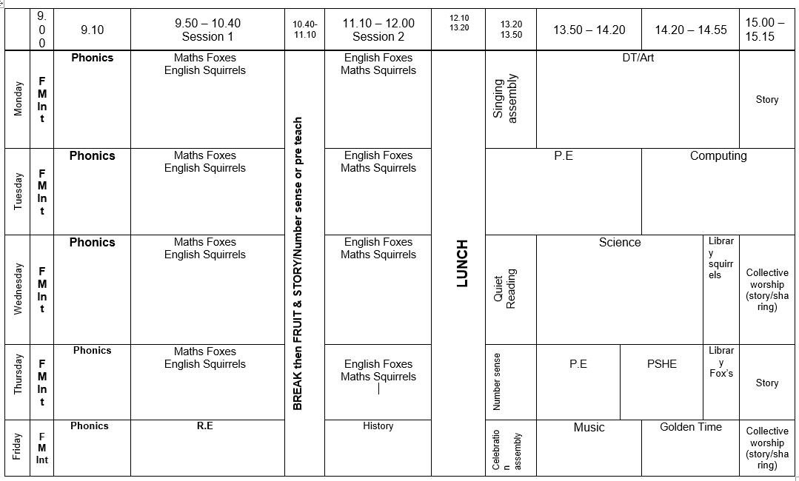
Weekly Timetable
We thought it might be useful for parents to have the weekly timetable so you can talk to your children about what they have been learning that day. You might ask them questions like “what did you find out about in History today?” “what did you make in Art today?”

Toys in School
We have noticed some children are bringing toys into school and also attaching valuable or sentimental keychains to their bookbags. Please could we make sure toys and valuables are kept at home as we would hate for the children to lose their important belongings.
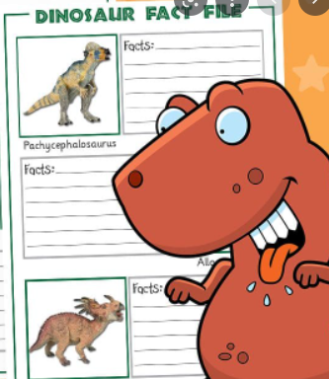
English
In English we will be writing a fact-file about Dinosaurs. You could research dinosaur facts with your child for them to bring to the lessons.
We will be learning about non-fiction books and how we can learn from them. Please share any non-fiction books with your child at home.

Maths

In Maths this week we are making equal groups, sharing and adding equal groups.

Adding equal groups-
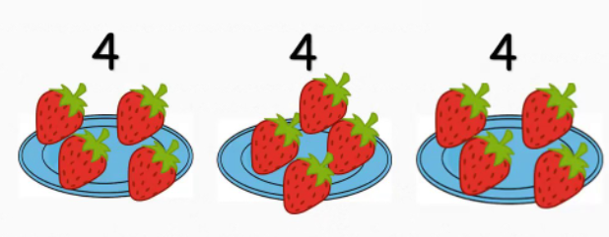
4 + 4 + 4 = Sharing
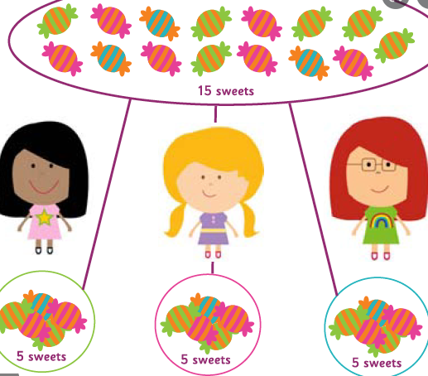

Reading

*Your child will read in a group with an adult each day. This will not be recorded in the reading diary. We will also listen to your child 1:1 each week and this will be recorded in the reading diary.
* Your child’s books will be changed once a week. They will be given 2 or 3 new books.
* One of the books they bring home will be a Read Write Inc book. This is the level they are working at and the sounds in these books will be covered in their phonics sessions.
* The other two books will be books to share at home. We do not expect your child to read these books independently – they are books that are sent home for you to enjoy together and to expand the children’s reading diet.
* Please ensure books bags are brought into school each day. Reading records should be filled in for any reading done at home - this should be done three times per week.
Helping at home
* Please hear your child read at least 3 times a week and write in the reading record book.
* Read to your child – bedtime stories are the BEST!
* Practise counting sets of objects – ensuring they understand the numbers to 10 securely. Don’t be tempted to go too far. 7

The children in year 1 now all have logins for purple mash. Please log into your child’s account and have an explore of the games and activities available to use. You will find their log in details in their reading record book.
https://2simple.com/purple-mash/
Please Remember –
- Children come in PE kit on Tuesdays and Thursdays.
- They will need a bag of spare clothes to keep on their peg.
- Please make sure your child has a named water bottle in school.
- Please return any library books in their library folders.

Many thanks for your support, The Year 1 Team

