Week of the 6th June – 10th June 2022
Bluebell Wood Bulletin

Our Year Two Team:
Owl class – Mrs Lewis (Monday to Thursday) and Mrs Davies (Friday), Miss Brooks, Mrs Phillips and Mrs Patel.

Hedgehog class – Mrs Turner (Monday, Tuesday and Friday) and Mrs Davies (Wednesday and Thursday), Mrs Brooks, Mrs Kaushal and Mrs Patel.

Wow! What a busy half term we have had! This week the children enjoyed the Woodley sports session and a country dancing lesson. We hope you all have a lovely half term.

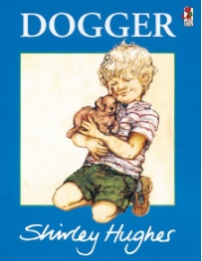
English:
This week we have read the story of Dogger and planned and written an adventure story about a toy getting lost and then found.

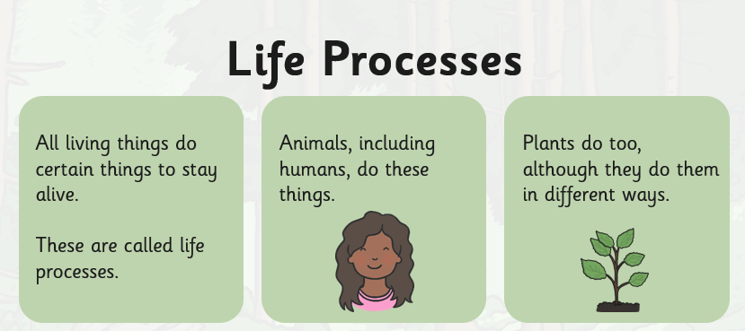
Science:
In science we have been learning about living processes. The children have been looking at life processes and sorting objects into different categories.

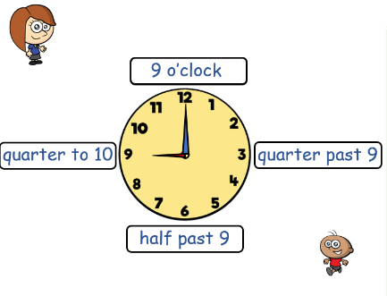
Maths:
This week in maths we have been learning about time. We have been using clocks to make the times quarter to and quarter past the hour. The children have been challenge to find and look at clocks at home.

Reading books:
Just to remind you that your child will have a set day that they are listened to read and are able to change their books. If they are on Read Write Inc (RWI) books they will take home one RWI book to read and two Oxford Reading Tree books to share. When an adult listens to your child read 1:1, it will be recorded in their reading record. Every child participates in a daily storybook lesson but this will not be recorded in their reading record.

Please ensure books bags are brought into school and reading records filled in for any reading done at home. Please listen to your child read at least three times a week.

If you, or anyone you know of, would be able to regularly volunteer to come in one afternoon and read with the children we would love to hear from you.

Please remember:
- Please make sure your child has a named water bottle in school.

- Please remember to make sure your child is wearing sun cream and brings a named hat to school.

- Year Two PE days are Monday and Wednesday. Please can your child come into school wearing the Willow Bank PE kit.

