Week 14th September –18th September 2020
Bluebell Wood Bulletin

English
This week we have continued learning the story ‘Norman the slug with the silly shell’ and actions to help us remember the story.
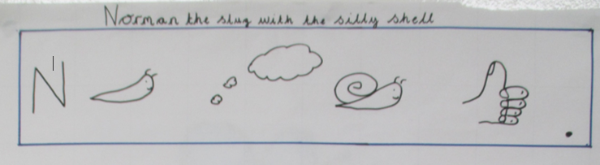

We have practised our key words from the text. Please continue to talk about these words at home and finding them in the books you read.
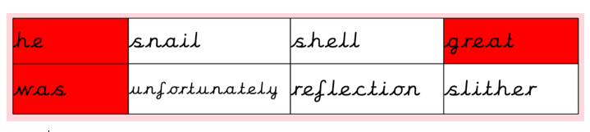

Activity: Please listen to your child read their school book or a book of their choosing at least three times a week. Please write in your child’s reading record every time you hear them read.

Maths
We are still focussing on place value and partitioning numbers into tens and ones using different apparatus.
We are continuing to order numbers up to 100 and making sure our numbers are formed correctly. We are also reading numbers in numerals and words.

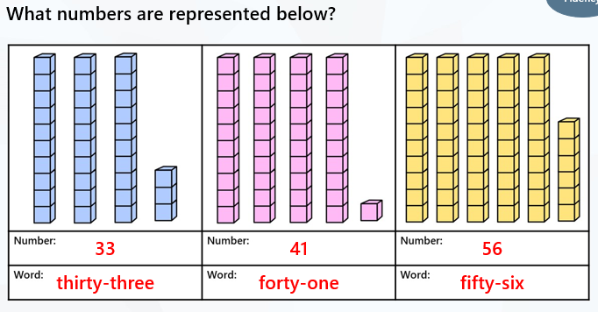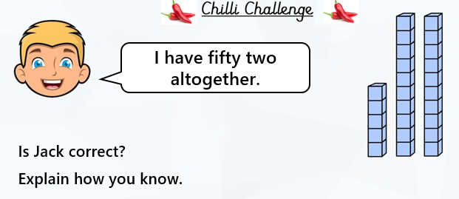

Reading:
Please use the Oxford Owl link below to login and access free e-books to read.
Look for the ‘My class login’ icon at the top of the page to login.
https://www.oxfordowl.co.uk/for-home/
Hedgehog class login details
My class name: hedgehogsjune
My class password: bluebell

Owl class login details
My class name: owlsjune
My class password: bluebell

Please Remember –
- At the moment children do not need to bring in a PE kit but they will need a bag of spare clothes to keep on their peg. We would appreciate it if this bag could include an art apron or old shirt.
- Please make sure your child has a named water bottle in school.
- As part of our topic ‘London’s burning’ we will be making Tudor Houses. We would be grateful if you could bring in a shoebox or cereal box so they can make their DT project.

