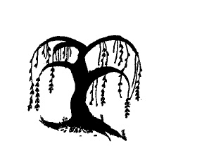

Literacy

Writing own name.

Labels, list and captions

Using story maps to retell stories

Guided write sessions
focusing on applying segmenting skills focusing on sentences

Hold a sentence

Writing sentences linking to focus text.

Writing instructions

Lunar New Year Poems

Maths
Time
Introduce 0
Compare numbers to 5
Composition of 4 and 5
Compare Mass
Compare capacity

Consolidate learning and understanding

Communication and Language

Retell a story

Talking about Chinese New Year/ Chinese New Year Story

Uses language to imagine and recreate roles and experiences in play situations.

Builds up vocabulary that reflects the breadth of their experiences – describing fruit

Year Group: Foundation Stage
Term: Spring 1 2022
Physical Development

Gymnastics
Lunar New Year dance
Healthy eating

Fine motor activities

Taking risks and developing gross motor skills using outside equipment

Expressive Arts and Design

Making calendars
Still life drawings of fruit.
Mosaics
Make a class Chinese dragon.
Chinese blossom trees

Dramatic role play opportunities

Copying African drum rhythms.

Understanding the World

Understand where things come from.

Look at different cultures from around the world.

The Lunar New Year

Shows an interest in ICT.

Completing different games/activities on a computer

Willow Bank Infant School
Personal Social Emotional Development

Growth mindset – Gem Power
What I like about School
Classroom rules
Look at our needs at different ages.
Likes and dislikes associated with food.
What makes me feel sad?
Helping others and being a kind friend.
What I can do and what I am good at.

Around the World

