Autumn 2 Monday 23rd November 2020
Our topic this term is “Celebrations”
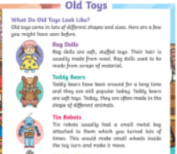
English – Toys Fact File
We will be linking our learning from History about toys with English this week. We will be writing a class fact file about toys and think about old and new toys. We hope the children enjoy writing about it as much as they have enjoyed looking at this so far.

Maths –
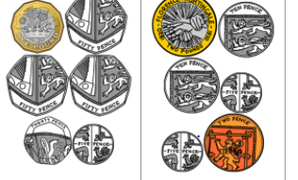
* In Maths we will be looking at money.
* We will be identifying coins and using them to count in 1s, 2s, 5s and 10s.
* We will be comparing the value of different coins.
* We will continue to use our problem solving and reasoning skills.

History
Thank you very much for the photographs we received of toys such as chopper bikes, train sets, conkers and teddy bears from many years ago – these really helped to bring this topic to life!
Requests We will be making our own toys made from recycled materials. Please could you send in any of the following- -Different shaped cardboard boxes -Washed yogurt pots –Straws -Cardboard tubes (excluding toilet rolls) -Different types of paper and card.
Helping at home
* Reading 4 x a week and recording it in the diary.
* Identify shapes in everyday life (e.g. wheels are circles, cereal boxes are cuboids and have rectangle faces)
* Handwriting – the children could help with writing a shopping list, writing a list of what they would like for lunch, or anything that has real-life use for you!
* Infant Encyclopaedia – A fantastic recourse to help your child get used to navigating the internet and using it to find out facts. https://infant.parkfieldprimary.com/
Reminders
*We will have two student teachers in our bubble on a Thursday for the next few months. You may see them or hear your child talking of them. They will be here to learn, help and support the children.
* We are beginning to get ready for Christmas. The songs we are singing are Three Blind Mice, Rudolph the Red Nosed Reindeer and We Wish You a Merry Christmas. You could help your child by practising these songs at home together!
* We will shortly be sending home letters regarding the virtual Christmas play and the costume your child will need. Thank you for your support, Miss Clift, Mrs Atkinson and Mrs Fillingham

