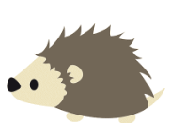
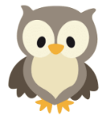
Week of the 13th – 17th September 2021
Bluebell Wood Bulletin

Our Year Two Team:
Owl class – Mrs Lewis (Monday to Thursday) and Mrs Davies (Friday), Mrs Holtham, Mrs Sidhu and Mrs Patel.

Hedgehog class – Mrs Turner (Monday, Tuesday and Friday) and Mrs Davies (Wednesday and Thursday), Mrs Brooks, Mrs Kaushal and Mrs Patel.

Our Learning:
English:
This week we have been learning about snails and started learning the story ‘Norman the slug with the silly shell’
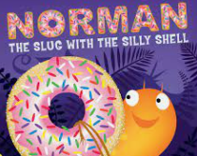

These are the speed words we have been learning from the book. Please talk about them with your child and spot them in the books you read together.

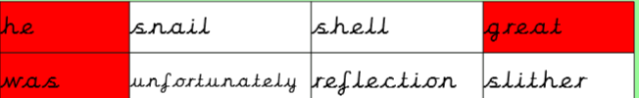

Maths:
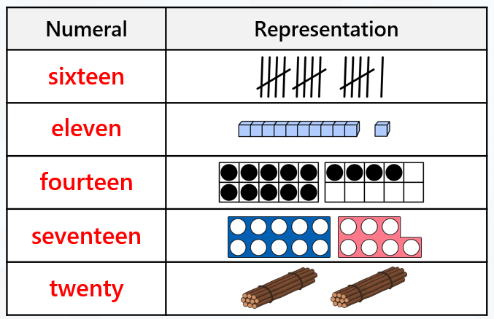
We have been representing numbers to 100 using a range of maths equipment.

Music:
We are learning about pitch and have been learning and listening to high and low sounds. In singing assembly we have been learning our school song.

Reading books:
Just to remind you that your child will have a set day that they are listened to read and are able to change their books. If they are on Read Write Inc (RWI) books they will take home one RWI book to read and two Oxford Reading Tree books to share. When an adult listens to your child read 1:1, it will be recorded in their reading record. Every child participates in a daily storybook lesson but this will not be recorded in their reading record.

Please ensure books bags are brought into school and reading records filled in for any reading done at home. Please listen to your child read at least three times a week.

If you, or anyone you know of, would be able to regularly volunteer to come in one afternoon and read with the children we would love to hear from you.

Please remember:
- Please make sure your child has a named water bottle in school.
- Year Two PE days are Monday and Wednesday. Please can your child come into school wearing the Willow Bank PE kit.
- If your child has received a certificate or award from outside of school we would love to see them and celebrate at school. These can be brought in on a Friday.
- On Thursday 23rd September we will be doing some art using natural materials. If your child could bring in any leaves, twigs, pebbles, conkers etc to help create their masterpiece we would be very grateful.

