Week of the 6th – 10th September 2021
Bluebell Wood Bulletin

Our Year Two Team:
Owl class – Mrs Lewis (Monday to Thursday) and Mrs Davies (Friday), Mrs Holtham, Mrs Sidhu and Mrs Patel.

Hedgehog class – Mrs Turner (Monday, Tuesday and Friday) and Mrs Davies (Wednesday and Thursday), Mrs Brooks, Mrs Kaushal and Mrs Patel.

Our Learning:
This week we have enjoyed the story ‘The Lighthouse Keeper’s Lunch.’

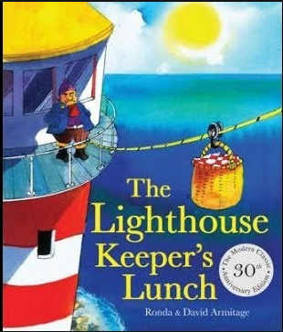

You can listen to the story using this link
https://www.youtube.com/watch?v=46wCRq50Wwg

English:
We have described and labelled the parts of a lighthouse and have explored the history of lighthouses. We have chosen our favourite character and written a short description of them. Did you know that the shape of a lighthouse was inspired by an oak tree!

Maths:
We have been representing numbers to 50 using a range of maths equipment. We have been comparing numbers using < > = symbols and have written numbers in words. We are starting to learn a new number-bonds song.

Art:
We have really enjoyed sculpting lighthouses using clay and creating lighthouse collages using tissue paper.

Music:
We have loved singing sea shanties and have listened to the musician Nathan Evans sing his sea shanties.

Reading books:
Just to remind you that your child will have a set day that they are listened to read and are able to change their books. If they are on Read Write Inc (RWI) books they will take home one RWI book to read and two Oxford Reading Tree books to share. When an adult listens to your child read 1:1, it will be recorded in their reading record. Every child participates in a daily storybook lesson but this will not be recorded in their reading record.

Please ensure books bags are brought into school and reading records filled in for any reading done at home. Please listen to your child read at least three times a week.

Please remember:
- Please make sure your child has a named water bottle in school.
- Please return any library books in their library folders.
- Year Two PE days are Monday and Wednesday. Please can your child come into school wearing the Willow Bank PE kit (green t-shirt, black shorts, black trainers or plimsolls and black jogging bottoms). Please can your child wear the Willow Bank School jumper on cold days (please remember no hoodies or football kits are permitted).

