Autumn 2 Monday 9th November 2020
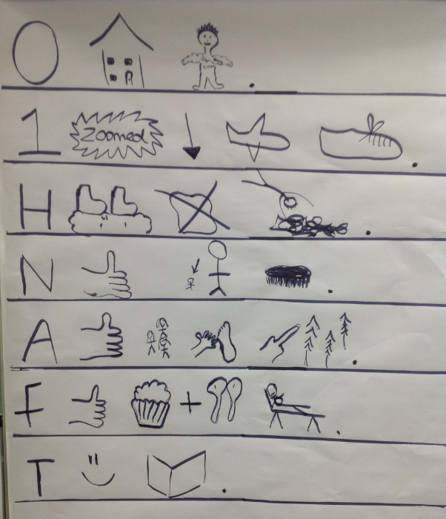
Our topic this term is “Celebrations”
English – Traction man
We are continuing to learn the story of traction man. Here is the story map, you could ask your child to retell it to you with the actions to practise!
We will be writing the story this week and thinking about how we could change it and write our own versions.

Maths – Subtraction
* In maths we will be using the subtraction sign.
* We will be using a number line to count backwards.
* We will continue to use our problem solving and reasoning skills.
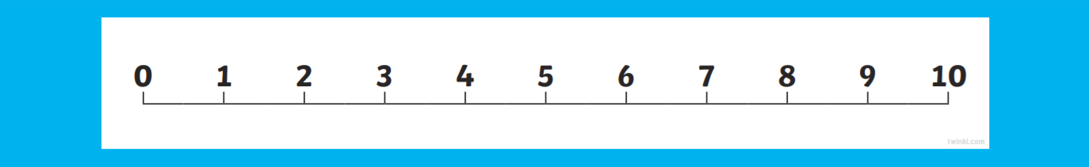

History
We will start learning about ‘new and old toys’ this week. 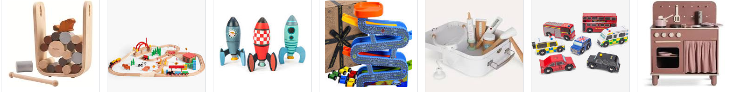Please could you bring or send in by email any photographs of any old toys that you or any grandparents may have played with in the past? We would love to share your memories with the children to compare toys now and as they used to be! (by Thursday 12th November please)
Thank you to those of you who have already sent these in.
We will also be making our own toys made from recycled materials. Please could you send in any of the following-
-Different shaped cardboard boxes -Washed yogurt pots –Straws -Cardboard tubes (excluding toilet rolls)
-Different types of paper and card.

Helping at home
* Reading 4 x a week and recording it in the diary.
* Practicing letter formation. (We will provide some handwriting sheets in bookbags)
* Practicing simple taking away within 10.
* Practice the number bonds to 10.
* Infant Encyclopaedia – A fantastic recourse to help your child get used to navigating the internet and using it to find out facts.
https://infant.parkfieldprimary.com/
Reminders
*Thank you to our helpers, we really apricate your time. If there are any other parents who would like to offer any help this term, please don’t hesitate to contact us.
*We will have two student teachers in our bubble on a Thursday for the next few months. You may see them or hear your child talking of them. They will be here to learn, help and support the children.
* We are beginning to get ready for Christmas and will shortly be sending home letters regarding the virtual Christmas play and the costume your child will need.
Thank you for your support,
Miss Clift, Mrs Atkinson and Mrs Fillingham

