End of Autumn 1 Bulletin

We have had a fun packed and busy half term. The children have settled in well and are enjoying the learning in Year 1. We will be moving into a more structured timetable next term, where there will be less free-flow time and more whole class learning.

Ideas for Half Term Home Learning
* Keep reading * Practice the number bonds to 10
* Next half term we will be writing a story, using the following vocabulary; first, next, then, after that, finally. If you are going out and about over the holiday you could use these words to talk about your day. * Share stories that include toys and have a chat to your children about what toys you used to play with. How are they different to what we play with now?

Autumn 2 Topic- Celebrations
Next term we will be moving on to an exciting new topic where one of our focuses will be ‘new and old toys’. 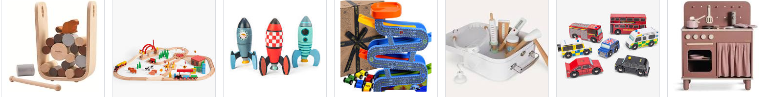Please could you bring or send in by email any photographs of any old toys that you or any grandparents may have played with in the past? We would love to share your memories with the children to compare toys now and as they used to be!
We will also be making our own toys made from recycled materials. Please could you send in any of the following-
-Different shaped cardboard boxes -Washed yogurt pots –Straws -Cardboard tubes (excluding toilet rolls)
-Different types of paper and card.
Finally, if you would be interested in becoming a volunteer parent helper next term please speak to Miss Clift or Mrs Atkinson. We would love to hear from you!
Enjoy your half term! Miss Clift, Mrs Atkinson and Mrs Fillingham.

