Week of the 27th June – 2022
Bluebell Wood Bulletin

Our Year Two Team:
Owl class – Mrs Lewis (Monday to Thursday) and Mrs Davies (Friday), Miss Brooks, Mrs Phillips and Mrs Patel.

Hedgehog class – Mrs Turner (Monday, Tuesday and Friday) and Mrs Davies (Wednesday and Thursday), Mrs Brooks, Mrs Kaushal and Mrs Patel.
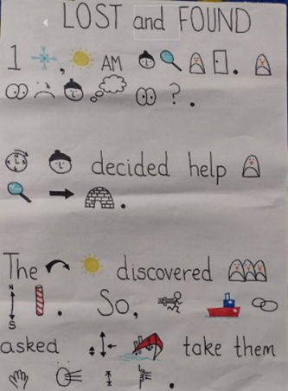
English:
This week we have been innovating our story and writing our own Lost and Found story.

Science:
In science we have been sorting animals into habitats around the world and thinking about how they are adapted to survive in different conditions.

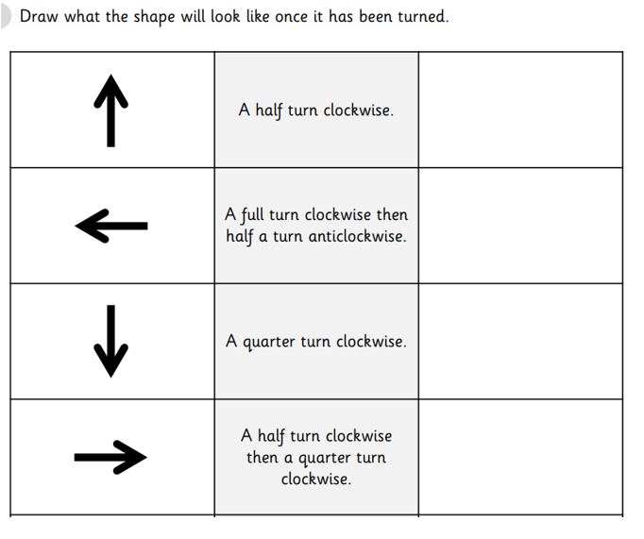

Maths:
This week in maths we have continued looking at position and direction. We have been describing and recording movements using the terms clockwise and anticlockwise.

Reading books:
Just to remind you that your child will have a set day to change their books. If they are on Read Write Inc (RWI) books they will take home one RWI book to read and two Oxford Reading Tree books to share. When an adult listens to your child read 1:1, it will be recorded in their reading record. Every child participates in a daily storybook lesson but this will not be recorded in their reading record.

Please ensure books bags are brought into school and reading records filled in for any reading done at home. Please listen to your child read at least three times a week.

If you, or anyone you know of, would be able to regularly volunteer to come in one afternoon and read with the children we would love to hear from you.

Please remember:
- Please make sure your child has a named water bottle in school.

- Please remember to make sure your child is wearing sun cream and brings a named hat to school.

- Year Two PE days are Monday and Wednesday. Please can your child come into school wearing the Willow Bank PE kit.

- Children should all have received a letter for our trip to Beale Park on the 14th of July. Please return the permission slip and medical form in a named envelope. Payment can be sent into the school fund account.

- Thank you for all the shoeboxes that you have brought in, we still need a few more so would appreciate any small boxes that you have.

- Tuesday 19th July. Leavers assembly in the afternoon. More details to follow.

- Wednesday 20th July Leavers breakfast.

