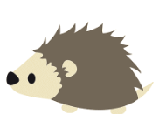
Week of the 2nd May –6th May 2022
Bluebell Wood Bulletin

Our Year Two Team:
Owl class – Mrs Lewis (Monday to Thursday) and Mrs Davies (Friday), Mrs Sidhu and Mrs Patel.

Hedgehog class – Mrs Turner (Monday, Tuesday and Friday) and Mrs Davies (Wednesday and Thursday), Mrs Brooks, Mrs Kaushal and Mrs Patel.

This week we have had to say goodbye to Mrs Sidhu. She has been a fantastic member of Owls class and she will be greatly missed by all the adults and children she has worked with. Miss Brooks and Mrs Phillips will be working in Owls class from Monday for the rest of this term.

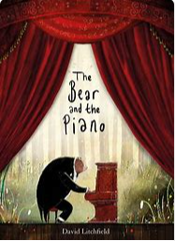
English:
This week we have been learning our new story ‘The Bear and the Piano’. The children have especially enjoyed looking at the illustrations. We will be using this text to plan and write our own adventure story.

Maths:
This week we have been recapping multiplication and division. The children have been focusing on solving word problems using different strategies.
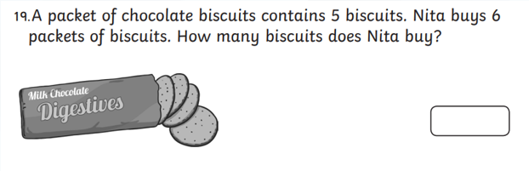

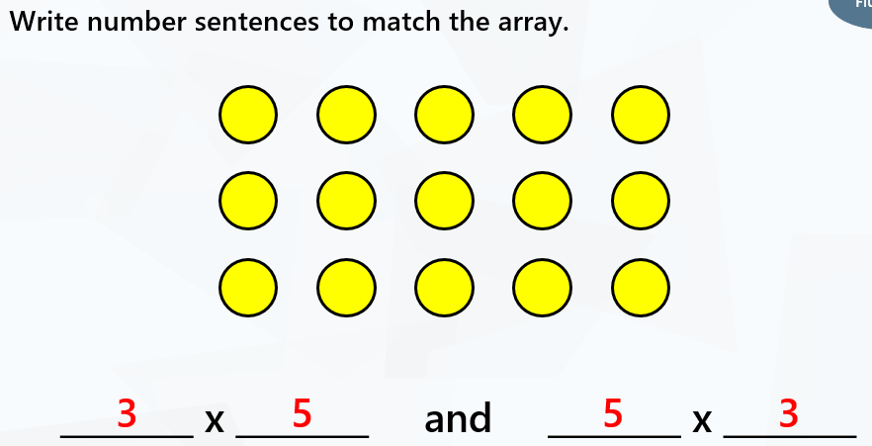

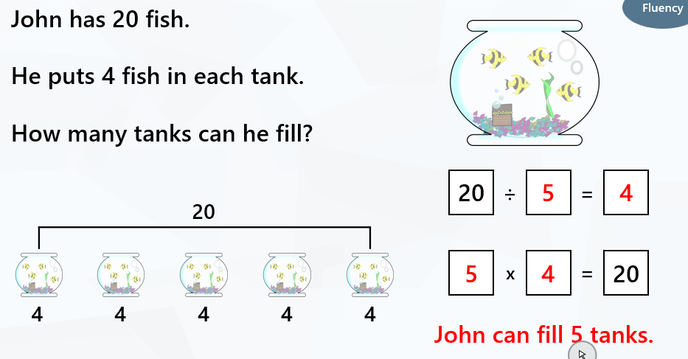

Science:
In science we have set up a comparative test to see what conditions plants need to grow best. We will observe and record our findings in our Bean diaries.

Reading books:
Just to remind you that your child will have a set day that they are listened to read and are able to change their books. If they are on Read Write Inc (RWI) books they will take home one RWI book to read and two Oxford Reading Tree books to share. When an adult listens to your child read 1:1, it will be recorded in their reading record. Every child participates in a daily storybook lesson but this will not be recorded in their reading record.

Please ensure books bags are brought into school and reading records filled in for any reading done at home. Please listen to your child read at least three times a week.

If you, or anyone you know of, would be able to regularly volunteer to come in one afternoon and read with the children we would love to hear from you.

Please remember:
- Please make sure your child has a named water bottle in school.

- Year Two PE days are Monday and Wednesday. Please can your child come into school wearing the Willow Bank PE kit.

- On Monday the 23rd of May we will be going to Woodford Park as part of Woodley Sports week. A letter will be sent out with further details.

Look, Say, Cover, Write and Check!

Tick the columns as you follow the instructions from left to right. Make sure you spell the words in the ‘write’ column. If you spell the word incorrectly, write it again in the correction column.

 | look | say | cover | Write | check | correction
bear
Melody
bounded
ventured
speedily
Dreamily
Joyful
loudly

