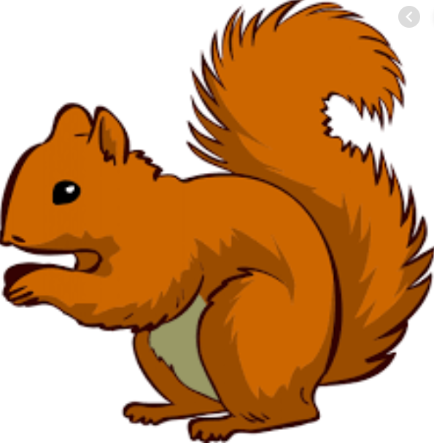
Week Beginning Monday 28th September 2020
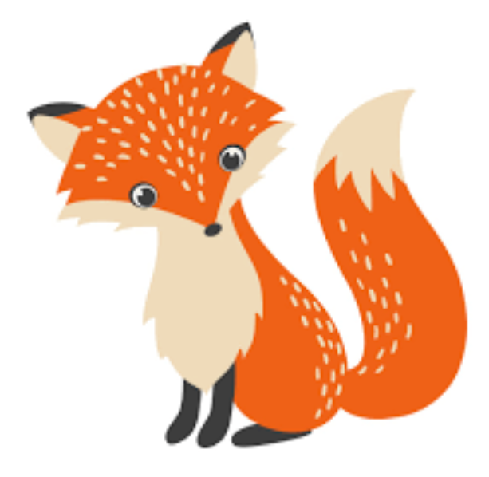
Topic – I am amazing!

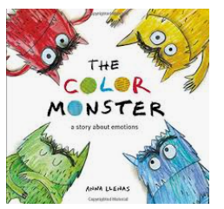
English – The Colour Monster
We are starting a new story called The Colour Monster. It is a delightful story that helps children talk about how to take care of ourselves and our emotions when we are feeling all mixed up. Over the next three weeks we will be learning it and turning it into a poem of our own!

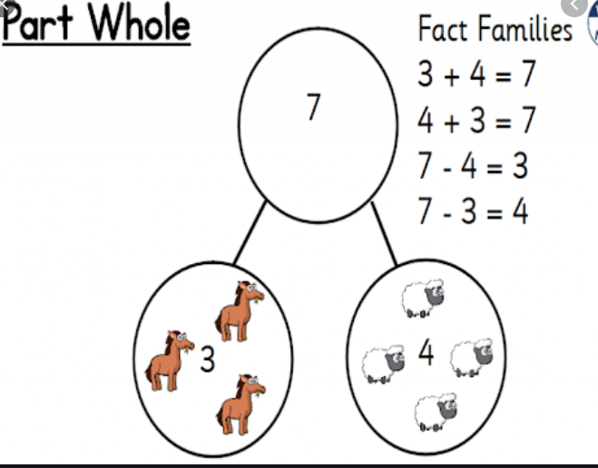
Maths – Whole-Part diagrams of numbers
* Number bonds within 10
* Recognising the + (addition) symbol
* Fact Families
* Number formation practise

Reading
We have loved seeing the children enjoy reading in the book corner and also listening to them read their own reading books. We understand that over lockdown it has been tricky to keep up with reading and so we would love the children to discover as many new books as possible this year. Please hear your child read at least 4 times a week and write in their reading record. This will allow them to learn the words in the book and enjoy the story too! We can then change your child’s reading book and help them enjoy more and more different stories each week.
Helping at home
* Read to your child – bedtime stories are the BEST!
* Ask your child questions like “What was your favourite part of the story?”
* Practise adding sets of objects – ensuring they understand the numbers to 20 securely. Don’t be tempted to go too far.
Key question- How many ways can we make 10? (1 + 9 = 10, 2 + 8 = 10…)

Donations
We would be really grateful for any of the following donations. We have already had some in and the children have loved using them all!
*Cotton Buds
*Golf tees
*Rice
*Dry noodles
*Flour
*Oats
*Lentils
*Junk modelling
These will greatly enhance our provision for the children. Many thanks in advance.
Many thanks Miss Clift, Mrs Atkinson and Mrs Fillingham

