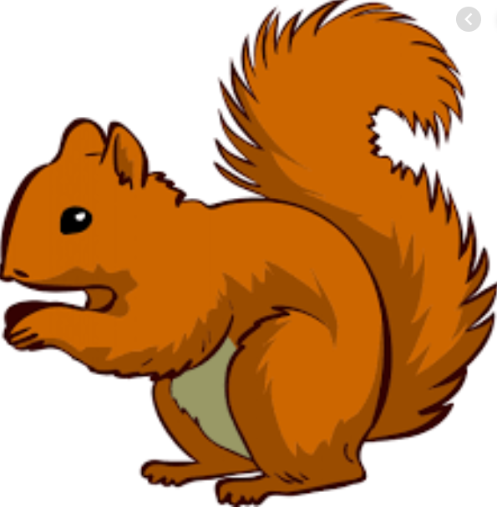
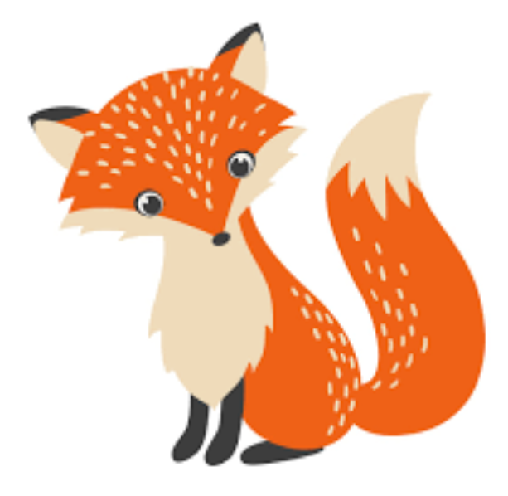
Week Beginning Monday 6th December 2021
Year 1 Bulletin
Squirrel Class Staff:
Mrs Atkinson and Mrs Fillingham - Class Teachers
Mrs Draper and Mrs McDonald - Teaching Assistants
Mrs Singh and Mrs Drummond - 1:1 Teaching Assistants
Support teacher- Mrs Leviss – Qualified Teacher, teaching across both classes

Fox Class Staff:
Miss Clift – Class Teacher
Mrs Smith and Mrs Hurst – Teaching Assistants
Mrs O’Reilly and Mrs Dobson – 1:1 Teaching Assistants
Mrs Morris and Mrs Redfern - 1:1 Teaching Assistants

.

New Social Distancing Measures
Thank you for your understanding this week as we reorganised start and end of the day arrangements for our classes. Just to confirm, these are as follows:
Squirrels come through Year 1 Garden in the morning and use the side gate to enter school. They go out of the main entrance in the afternoon. Parents to wait by the sensory garden by the main entrance for Squirrels children at the end of the day.
Foxes come in through Fox classroom door at the beginning and end of the day.
If you have any questions about this, please do ask you Class Teacher.

Dates for the diary
Your child has been given a part in the Christmas play. Please help them to learn their lines if they have any and please bring their outfit to school in the named bag by Monday 6th of December.
Monday 6th December is panto day! School lunch provided will be hot dog and chips
Our performance will be filmed on Wednesday the 8th of December. This will then be available for you to watch asap.

English – Fact file
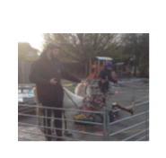
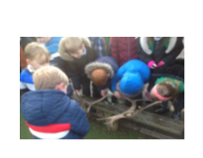
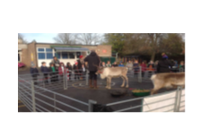
We will be writing fact files about Reindeers. We will be using everything that we learnt from our surprise reindeer visit to write these. You could ask your child what they can remember from the visit.
What do they eat?
Where are they from?
What happens to their antlers?

Maths – Numbers to 20
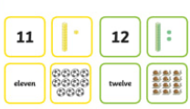
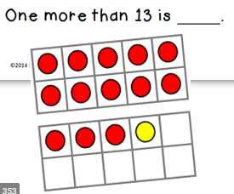
In Maths this week we will be looking at:
- Tens and ones
- Count one more and one less
- Comparing groups of objects

Phonics
Your child may tell you they are now working with a different adult for phonics. However, the levels have not changed. We have restructured the groups so that Year 1 and Year 2 are no longer mixing. This is so that we can make sure everyone is as safe as possible based on guidelines from Wokingham Borough Council.
Phonics assessments will take place in the next couple of weeks, ready for next term.
Reading
*Your child will read in a group with an adult each day. This will not be recorded in the reading diary. We will also listen to your child 1:1 each week and this will be recorded in the reading diary.
* Your child’s books will be changed once a week. They will be given 2 or 3 new books.
* One of the books they bring home will be a Read Write Inc book. This is the level they are working at and the sounds in these books will be covered in their phonics sessions.
* The other two books will be books to share at home. We do not expect your child to read these books independently – they are books that are sent home for you to enjoy together and to expand the children’s reading diet.

* Please ensure books bags are brought into school each day. Reading records should be filled in for any reading done at home - this should be done three times per week.
Helping at home
* Please hear your child read at least 3 times a week and write in the reading record book.
* Read to your child – bedtime stories are the BEST!
* Practise counting sets of objects – ensuring they understand the numbers to 10 securely. Don’t be tempted to go too far. 7

The children in year 1 now all have logins for purple mash. Please log into your child’s account and have an explore of the games and activities available to use. You will find their log in details in their reading record book.
https://2simple.com/purple-mash/

Library day will be on a Wednesday for Squirrels and a Thursday for Foxes. If your child would like to change their book please ensure they bring their library folder and book to school on their library day.

Please Remember –
- Children come in PE kit on Tuesdays.
- They will need a bag of spare clothes to keep on their peg.
- Please make sure your child has a named water bottle in school.
- Please return any library books in their library folders.

Many thanks for your support, The Year 1 Team

