Autumn 2 Monday 30th November 2020
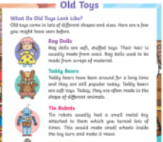
Our topic this term is “Celebrations”
English – Toys Fact File
We will be continuing with our non-fiction writing about toys. The children have practised writing facts about new and old toys with a big emphasis on using capital letters, finger spaces, full stops and checking it makes sense. This week the chilren will put the information learnt into a fact file.

Maths –
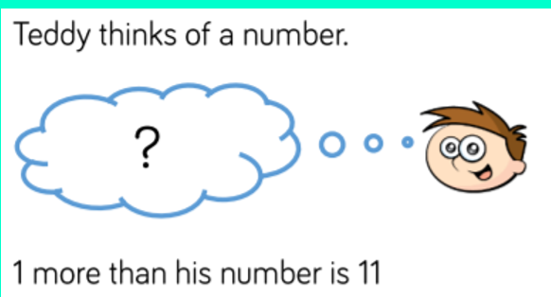
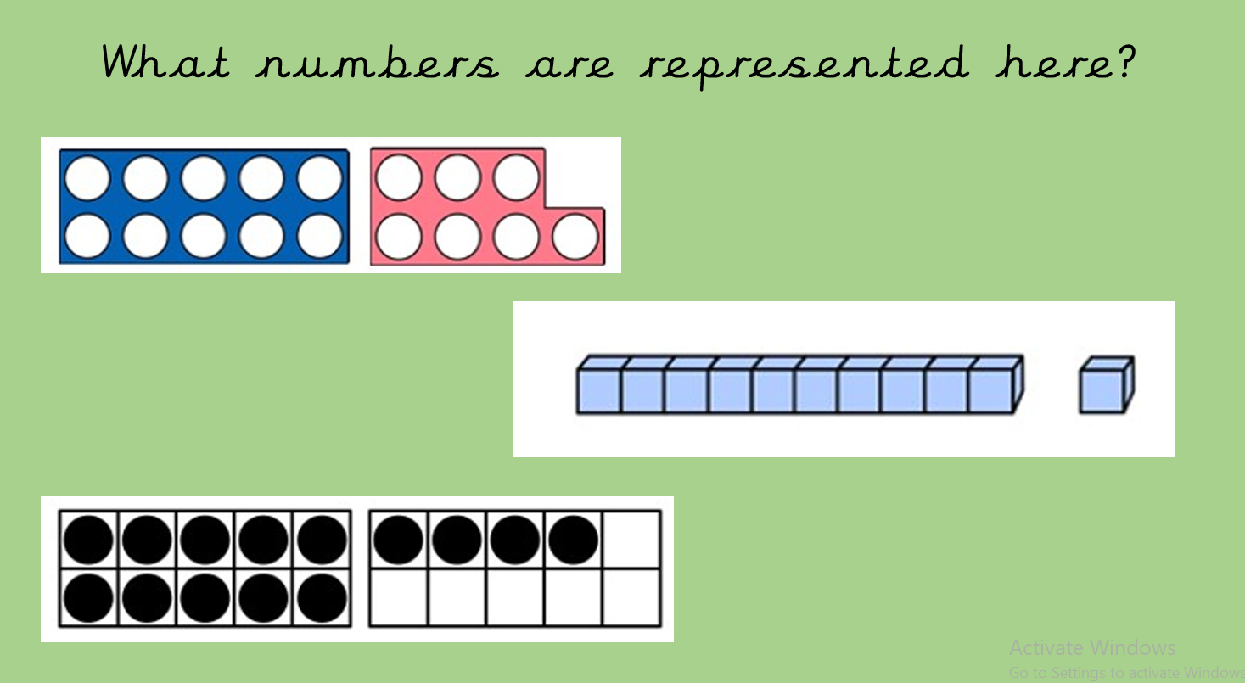
* In Maths we will be looking at ways to represent numbers.
* We will be identifying one more and one less than given numbers.
* We will be comparing pictorial (pictures) and abstract (written digits) representations of numbers between 1-20.
* We will continue to use our problem solving and reasoning skills.

Helping at home
* Reading 4 x a week and recording it in the diary.
* Identify, read and record numbers from everyday life (e.g. football scores, scores in games/ on TV shows). Focus on making sure the numbers are the correct way round.
* Handwriting – the children could help with writing a shopping list, writing a list of what they would like for lunch, or anything that has real-life use for you!
* Infant Encyclopaedia – A fantastic recourse to help your child get used to navigating the internet and using it to find out facts. https://infant.parkfieldprimary.com/

Home learning
Hi Foxes and Squirrels, we are sorry we have not been able to see you today but we look forward to seeing you next week on teams
Home learning will commence from Monday 30th and all material will be uploaded to Microsoft teams. If you haven’t received it already, our log in details will be available to pick up from the school office. We will be available by email to answer any questions by email between 9am-3.15pm.
Miss Clift Mon-Fri cclift@willowbank-inf.wokingham.sch.uk
Mrs Atkinson Mon-Thurs catkinson@willowbank-inf.wokingham.sch.uk
Mrs Fillingham Fri rfillingham@willowbank-inf.wokingham.sch.uk

Many thanks and stay safe, Miss Clift, Mrs Atkinson and Mrs Fillingham

