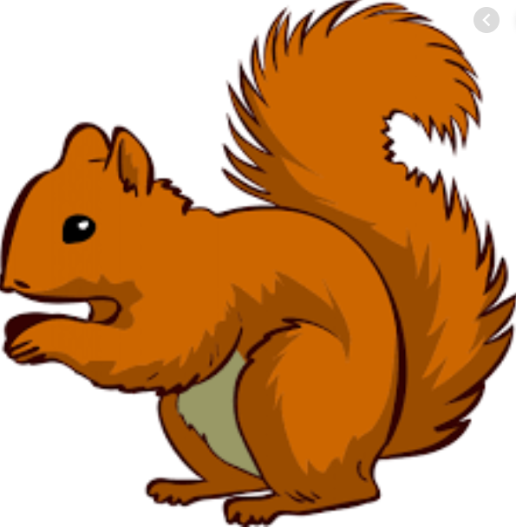
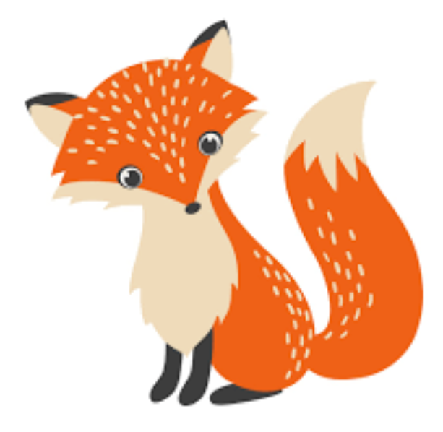
Week Beginning Monday 13th December 2021
Year 1 Bulletin
Squirrel Class Staff:
Mrs Atkinson and Mrs Fillingham - Class Teachers
Mrs Draper and Mrs McDonald - Teaching Assistants
Mrs Singh and Mrs Drummond - 1:1 Teaching Assistants
Support teacher- Mrs Leviss – Qualified Teacher, teaching across both classes

Fox Class Staff:
Miss Clift – Class Teacher
Mrs Smith and Mrs Hurst – Teaching Assistants
Mrs O’Reilly and Mrs Dobson – 1:1 Teaching Assistants
Mrs Morris and Mrs Redfern - 1:1 Teaching Assistants

.

Dates for the diary
Tuesday 14th – Year 1 Elfridges (Children will shop for a present for a family member)
Wednesday 15th – Christmas jumper day (Please wear a Christmas jumper instead of your school jumper)
Thursday 16th – Christmas party day (Please come in party clothes but sensible shoes. Please provide a “Party” snack for the afternoon e.g- crisps, cake bar, popcorn, mini Haribo or a cereal bar)

We will collect all of the children’s reading and library books in before Christmas. Please ensure you return any books that you have at home.

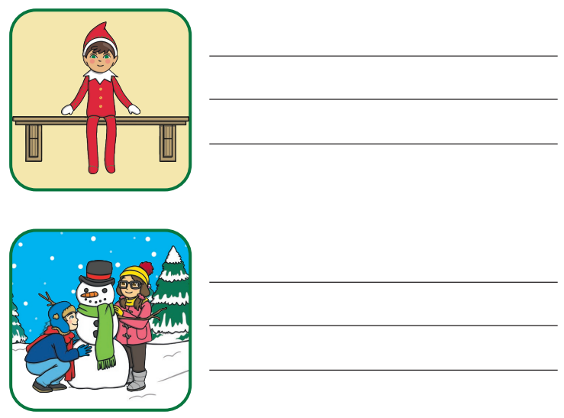
English –
We will be writing Christmas captions and answering questions about a Christmas text.

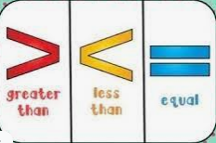
In Maths this week we will be looking at:

- Comparing numbers to 20 using the symbols
- Ordering numbers to 20

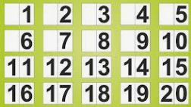

Phonics
Your child may tell you they are now working with a different adult for phonics. However, the levels have not changed. We have restructured the groups so that Year 1 and Year 2 are no longer mixing. This is so that we can make sure everyone is as safe as possible based on guidelines from Wokingham Borough Council.
Phonics assessments will take place in the next couple of weeks, ready for next term.

Reading
*Your child will read in a group with an adult each day. This will not be recorded in the reading diary. We will also listen to your child 1:1 each week and this will be recorded in the reading diary.
* Your child’s books will be changed once a week. They will be given 2 or 3 new books.
* One of the books they bring home will be a Read Write Inc book. This is the level they are working at and the sounds in these books will be covered in their phonics sessions.
* The other two books will be books to share at home. We do not expect your child to read these books independently – they are books that are sent home for you to enjoy together and to expand the children’s reading diet.

* Please ensure books bags are brought into school each day. Reading records should be filled in for any reading done at home - this should be done three times per week.
Helping at home
* Please hear your child read at least 3 times a week and write in the reading record book.
* Read to your child – bedtime stories are the BEST!
* Practise counting sets of objects – ensuring they understand the numbers to 10 securely. Don’t be tempted to go too far. 7

The children in year 1 now all have logins for purple mash. Please log into your child’s account and have an explore of the games and activities available to use. You will find their log in details in their reading record book.
https://2simple.com/purple-mash/

Please Remember –
- Children come in PE kit on Tuesdays.
- They will need a bag of spare clothes to keep on their peg.
- Please make sure your child has a named water bottle in school.
- Please return any library books in their library folders.

Many thanks for your support, The Year 1 Team

