Week 28th September –2nd October 2020
Year Two Class Bulletin

Topic:
This week we had our Great Fire of London workshop. We had lots of fun transporting ourselves back to 1666 and taking part in different drama activities. We have many budding actors in the making!

English
To link with our topic ‘London’s Burning’, we will be looking at the book ‘Vlad and the Great Fire of London’. It tells the story of the Great Fire of London through the eyes of Vlad the Flea and his friend Boxton the rat.
This week we ‘received’ a letter from Samuel Pepys to King Charles 2nd telling him about the fire in Pudding Lane. We are learning the key features of a letter, ready to write our own letter.

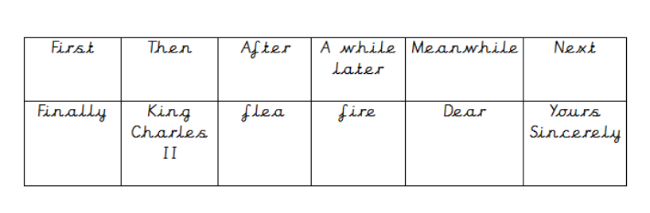
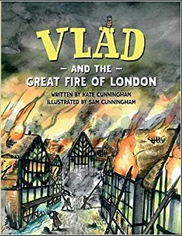

Activity: Please listen to your child read their school book or a book of their choosing at least three times a week. Please write in your child’s reading record every time you hear them read.

Maths
We have been comparing and ordering numbers up to 100 and we have been counting forwards and backwards in 3s and continuing to count in 2s, 5s, and 10s.

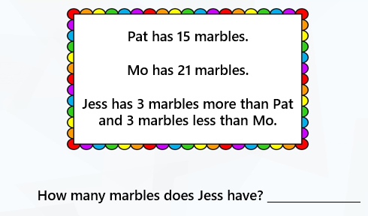
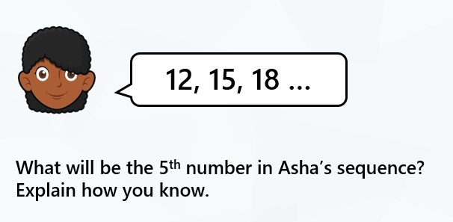

Reading:
Please use the Oxford Owl link below to login and access free e-books to read.
Look for the ‘My class login’ icon at the top of the page to login.
https://www.oxfordowl.co.uk/for-home/
Hedgehog class login details
My class name: hedgehogsjune
My class password: bluebell

Owl class login details
My class name: owlsjune
My class password: bluebell

Your child will be coming home with a ‘Red Word Mat’ in their bookbags. Red words need to be learnt by sight recognition and cannot be sounded out. We practise reading and writing these words in school as part of our daily phonics and you can practise these words at home too. You can look for them in your child’s reading book and books you share together. You could have a go at writing them.
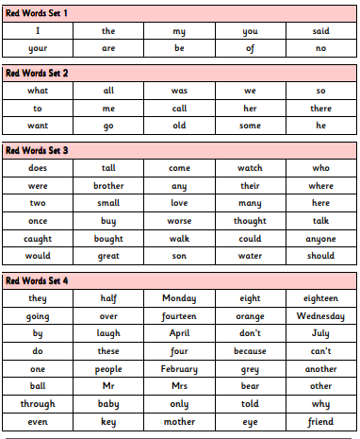

Please Remember –
- As part of our topic ‘London’s burning’ we will be making Tudor Houses. We would be grateful if you could bring in a shoebox or cereal box so they can make their DT project. Thank you for all the boxes you have brought in so far.

