Autumn 2 Monday 16th November 2020
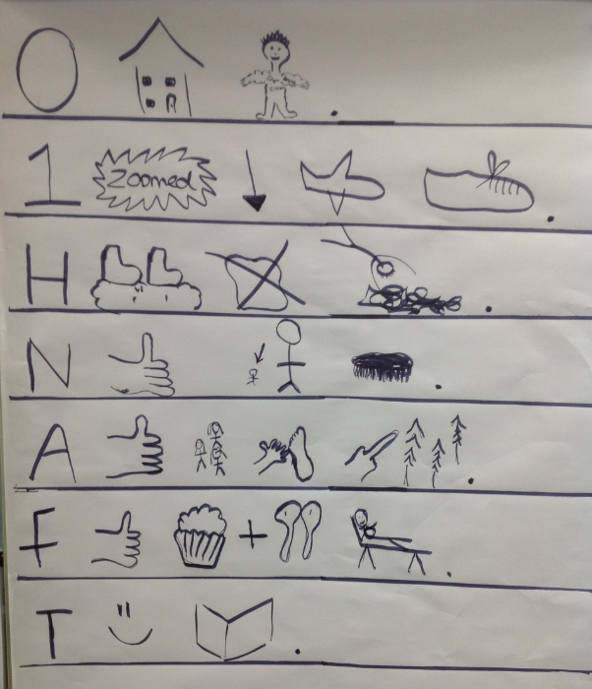
Our topic this term is “Celebrations”
English – Traction man
We are continuing to learn the story of Traction Man. We will be adapting and rewriting the story this week with the children’s own ideas. You could talk through some ideas for changes with your child. For example, instead of ‘He jumped on pillows, guarded the toast and dived into foamy waters’ you could say ‘He jumped on the duvet, guarded the cat and dived into the deep blue sink’.

Maths – Subtraction
* In Maths we will be looking at 2D and 3D shapes.
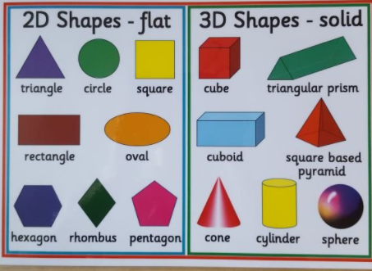
* We will be naming shapes and thinking about their properties.
* We will continue to use our problem solving and reasoning skills.

History
Last week, we introduced the Toy Shop in the gallery area for our children to start exploring ‘New and Old Toys’. Thank you very much for the wonderful photographs of toys old and new – we will be exploring these more formally this week.
We also created wonderful Year 1 display based on the celebration of Remembrance Day. The children thought about why people fought in the war and produced fantastic writing about this. They all produced silhouettes, painted a background sky and made poppies of their very own. They used a wide variety of skills such as painting, cutting and pencil control. A fabulous learning experience for all!
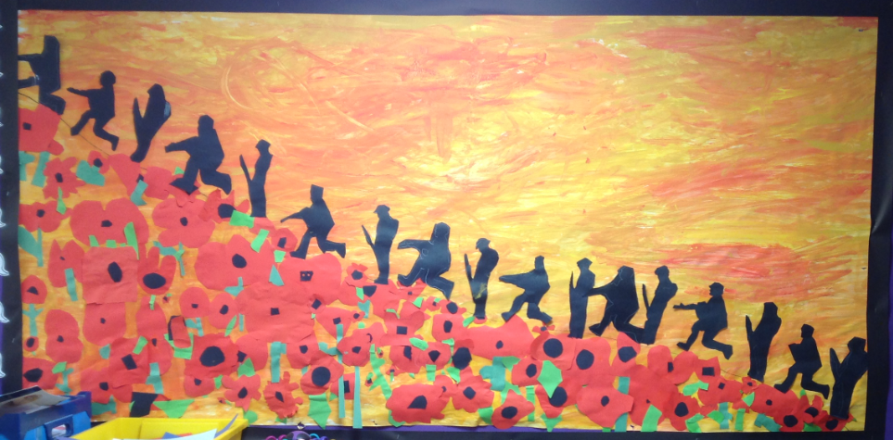

Requests
Please could you check the label in your child’s jumper. We currently have a missing jumper which is named but have not been returned yet to its owner – we would be very grateful if you could check this to make sure it has not been picked up by mistake.
We will also be making our own toys made from recycled materials. Please could you send in any of the following-
-Different shaped cardboard boxes -Washed yogurt pots –Straws -Cardboard tubes (excluding toilet rolls)
-Different types of paper and card.
Helping at home
* Reading 4 x a week and recording it in the diary.
* Identify shapes in every day life (e.g. wheels are circles, cereal boxes are cuboids and have rectangle faces)
* Handwriting – the children could help with writing a shopping list, writing a list of what they would like for lunch, or anything that has real-life use for you!
* Infant Encyclopaedia – A fantastic recourse to help your child get used to navigating the internet and using it to find out facts. https://infant.parkfieldprimary.com/
Reminders
*Thank you to our helpers, we really appreciate your time. If there are any other parents who would like to offer any help this term, please don’t hesitate to contact us.
*We will have two student teachers in our bubble on a Thursday for the next few months. You may see them or hear your child talking of them. They will be here to learn, help and support the children.
* We are beginning to get ready for Christmas. The songs we are singing are Three Blind Mice, Rudolph the Red Nosed Reindeer and We Wish You a Merry Christmas. You could help your child by practising these songs at home together!
* We will shortly be sending home letters regarding the virtual Christmas play and the costume your child will need. Thank you for your support,
Miss Clift, Mrs Atkinson and Mrs Fillingham

