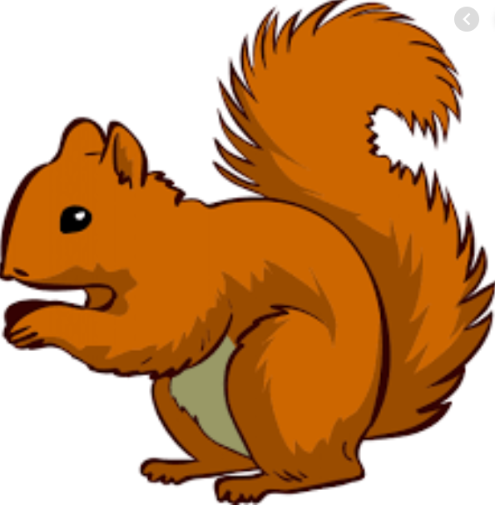
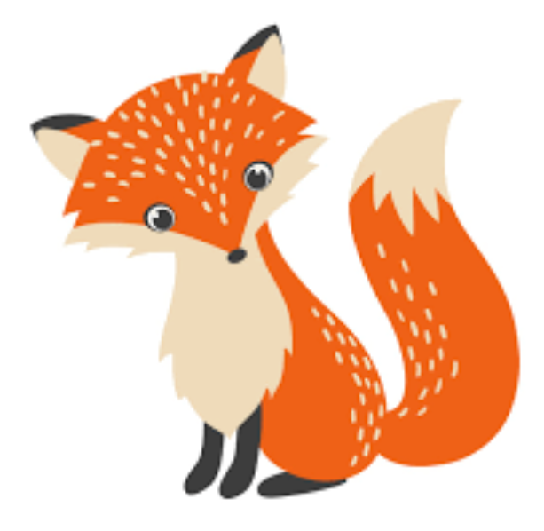
Week Beginning Monday 7th February 2022
Year 1 Bulletin
Squirrel Class Staff:
Mrs Atkinson and Mrs Fillingham - Class Teachers
Mrs Draper and Mrs McDonald - Teaching Assistants
Mrs Singh and Mrs Drummond - 1:1 Teaching Assistants
Support teacher- Mrs Leviss – Qualified Teacher, teaching across both classes

Fox Class Staff:
Miss Clift – Class Teacher
Mrs Smith and Mrs Hurst – Teaching Assistants
Mrs O’Reilly and Mrs Dobson – 1:1 Teaching Assistants
Mrs Morris and Mrs Redfern - 1:1 Teaching Assistants

.

Gem Week
This term, we have been thinking about good choices using our Gem Power. This week we will be thinking about how we use Gem Power in all our learning. We can’t wait to You could to your children about how we can use Gem Power in our every day life.

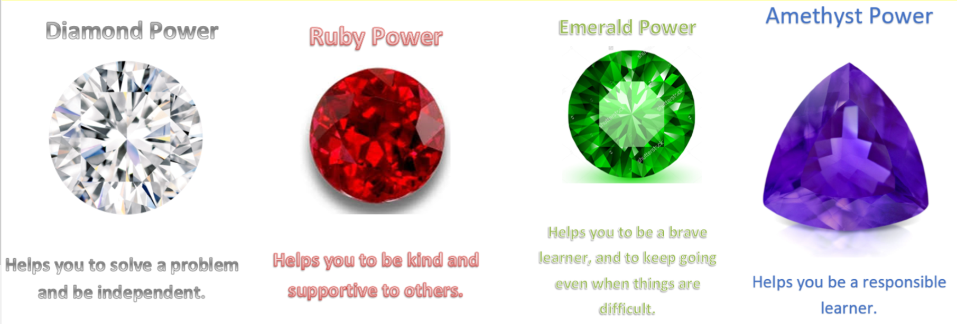

Microsoft Teams
We are now uploading our learning onto Teams for children who are isolating at home due to Covid-19. We will be uploading the learning the night before or the morning of the lessons are due to be taught at school. Please refer the Timetable for the week which you can find on our website with this newsletter or on Teams. We are aware that everyone’s situations will be different and Covid-19 continues to be prove challenging. Therefore, children can have a week to submit learning online (so they do not have to do it on the exact day it is set) to allow for differences in circumstance and situations. Children do not have to submit learning if they are unwell.
English
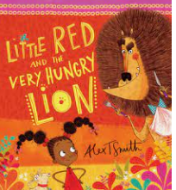
In English we have loved reading the story of “Little Red and the Very Hungry Lion”.
We will be continuing to use this story as a stimulus and thinking about how we can use Gem Power to help the characters make better choices. This week we will be writing a Diary entry from Little Red. Using the days of the week. You could practise spelling the days of the week with your child.

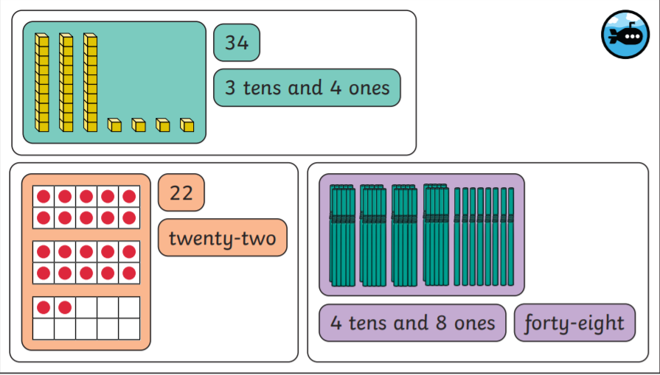
In Maths this week we will be-
Comparing number sentences
Exploring composition of numbers from 1-50
Ordering numbers
Finding 1 more and 1 less
Counting on a number track forwards and backwards to 50.

You could ask your child how many tens and ones are
In numbers from 11-50.

Reading – Due to staff shortages, we apologise in advance if your child has not been heard read this week. We will however, ensure they have their books changed by Friday.
*Your child will read in a group with an adult each day. This will not be recorded in the reading diary. We will also listen to your child 1:1 each week and this will be recorded in the reading diary.
* Your child’s books will be changed once a week. They will be given 2 or 3 new books.
* One of the books they bring home will be a Read Write Inc book. This is the level they are working at and the sounds in these books will be covered in their phonics sessions.
* The other two books will be books to share at home. We do not expect your child to read these books independently – they are books that are sent home for you to enjoy together and to expand the children’s reading diet.
* Please ensure books bags are brought into school each day. Reading records should be filled in for any reading done at home - this should be done three times per week.
Helping at home
* Please hear your child read at least 3 times a week and write in the reading record book.
* Read to your child – bedtime stories are the BEST!
* Practise counting sets of objects – ensuring they understand the numbers to 10 securely. Don’t be tempted to go too far. 7
The children in year 1 now all have logins for purple mash. Please log into your child’s account and have an explore of the games and activities available to use. You will find their log in details in their reading record book.
https://2simple.com/purple-mash/

Please Remember –
- Children come in PE kit on Tuesdays and Thursdays.
- They will need a bag of spare clothes to keep on their peg.
- Please make sure your child has a named water bottle in school.
- Please return any library books in their library folders.

Many thanks for your support, The Year 1 Team

