Week of the 20th – 24th September 2021
Bluebell Wood Bulletin

Our Year Two Team:
Owl class – Mrs Lewis (Monday to Thursday) and Mrs Davies (Friday), Mrs Holtham, Mrs Sidhu and Mrs Patel.

Hedgehog class – Mrs Turner (Monday, Tuesday and Friday) and Mrs Davies (Wednesday and Thursday), Mrs Brooks, Mrs Kaushal and Mrs Patel.

Our Learning:
English:
This week we have been using ‘Talk for Writing’ to retell the story ‘Norman the Slug with the Silly Shell’
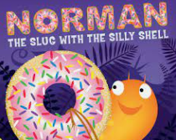

These are the speed words we have been learning from the book. Please talk about them with your child and spot them in the books you read together.

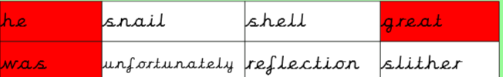

Maths:
We have been ordering numbers to 100 from smallest to greatest and counting in 2s, 5s and 10s forwards and backwards.

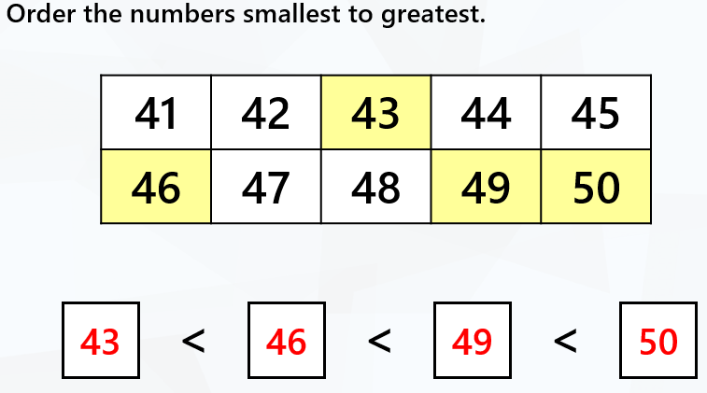
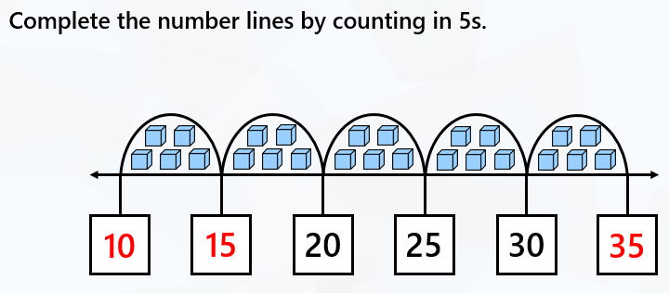

Music:
We are learning about pitch and have been learning and listening to high and low sounds. We used Xylophones to make high and low pitch sounds.
In singing assembly, we have been learning one of our harvest songs ‘Cauliflowers Fluffy’.

History and Geography:
We have been comparing old and new buildings in London and discussing the materials that were used.

Art:
Using Andy Goldsworthy as our inspiration, we made our own transient natural art using leaves, twigs, flowers and pine cones to create snails.

Science:
We have been outside this week recording all the different materials that have been used in our school and playground. We are beginning to explain the properties and suitability of different materials.

ICT:
We have been discussing how we use information technology in our school and in our homes. We sorted objects that do and don’t use information technology.

RE:
This week we looked at Bear Grylls as an inspirational Christian scouting leader. We discussed Jesus’ disciples and used role-play to explore the story of how they met.

Reading books:
Just to remind you that your child will have a set day that they are listened to read and are able to change their books. If they are on Read Write Inc (RWI) books they will take home one RWI book to read and two Oxford Reading Tree books to share. When an adult listens to your child read 1:1, it will be recorded in their reading record. Every child participates in a daily storybook lesson

but this will not be recorded in their reading record.

Please ensure books bags are brought into school and reading records filled in for any reading done at home. Please listen to your child read at least three times a week.

If you, or anyone you know of, would be able to regularly volunteer to come in one afternoon and read with the children we would love to hear from you.

Please remember:
- Please make sure your child has a named water bottle in school.
- Year Two PE days are Monday and Wednesday. Please can your child come into school wearing the Willow Bank PE kit.
- If your child has received a certificate or award from outside of school we would love to see them and celebrate at school. These can be brought in on a Friday.
- On Thursday 30th September we have the Great Fire of London workshop.
- We will be making Tudor houses in DT this term and we need many boxes as possible! We need donations of large cereal boxes and shoe boxes. Many thanks.

