4th – 8th January 2021
Year Two Class Bulletin

Hello Owls and Hedgehogs,

We are so sad they we are not in school again. It seems ages since we last saw you. We hope you all had a wonderful Christmas break.

It has been lovely to see so many of you on our Teams chats this week and to see all the wonderful, amazing and noisy presents you received for Christmas. Drop ins are daily at 9.30 for boys and 11am for the girls. We hope to see some more of you next week.

We know it is tricky juggling work, home school and general homelife so thank you for your patience and understanding as we get to grips with Teams again and all the technical glitches we have faced this week. We aim to have the work for the week ahead uploaded by the Friday evening so you have time to prepare for the week head.

All work is uploaded to Teams and can be found in the files section, Spring week _, each subject has its own folder and each day has a file with the day on it.

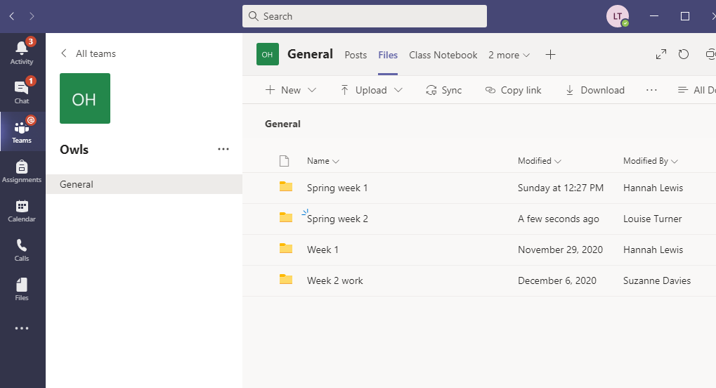

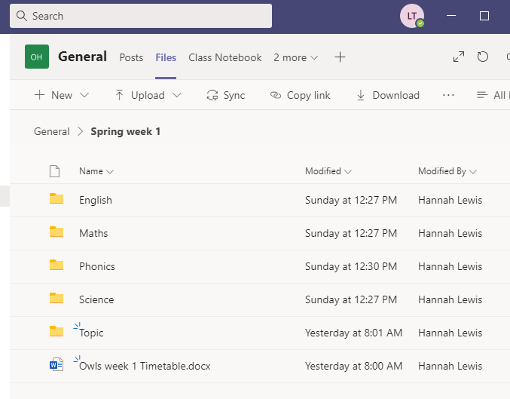

In each folder there will be files for the week in different formats. This is so people using different devices can access the work. Please pick the file format which is most suitable for you. For Maths and English the Power Point presentations have voiceovers for each day. To access the voiceovers you will need to download the Power Point to your device first. The voiceovers do not work on the PDFs or any other formats.

The script we are using in our English for the Gorilla story is saved in the English week 2 file.

Assignments can be found under the assignments tab of Teams. Click on the assignments tab on the left hand side of Teams and scroll down to the bottom to find the most recent assignments. If there is no assignment set for a particular piece of work and you would like to send it in you can attach it to another assignment and upload it or email it through to us.

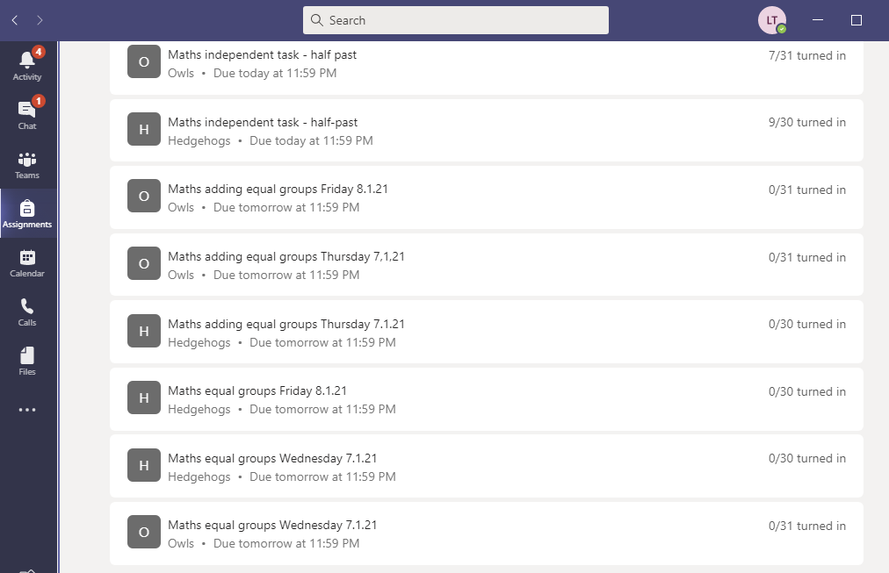

In the newsletter this week Mrs Masters will be writing to you about virtual Gem nominations for your child, if they have shown a particular Gem power in their home learning. As part of the PSHE home learning next week there will be a Power Point explaining the different Gems we use and what they mean.

Queries about work can be emailed to us on:
hlewis@willowbank-inf.wokingham.sch.uk (Monday- Thursday)
lturner@willowbank-inf.wokingham.sch.uk (Monday, Tuesday and Friday)
sdavies@willowbank-inf.wokingham.sch.uk (Wednesday, Thursday, Friday)
We will endeavour to answer all emails sent during school hours the same day, otherwise they will be answered the next working day. Feed back will be given twice a week for maths and English and we will have daily drop in sessions.

You should all still have logins for Purple Mash and Education City which have lots of games and activities that compliment what the children are learning. If you sign up to Oxford Owl you can access lots of books online. We have added some other websites that might be useful for additional activities.
https://go.educationcity.com/?_ga=2.244359744.496286403.1609857965-881931223.1609857965

https://www.purplemash.com/sch/wbinfant

https://www.oxfordowl.co.uk/please-log-in

https://www.bbc.co.uk/bitesize/levels/z3g4d2p BBC bitesize have lots of additional lessons that you can access to compliment what the children are doing in their home learning.

https://www.phonicsplay.co.uk/ Phonics play have set up a new free login for parents to access at home.
Username: jan21
Password: home

https://www.ictgames.com/ On this website there is a selection of Literacy and Maths games.

