Week Beginning Monday 7th^{th} September 2020
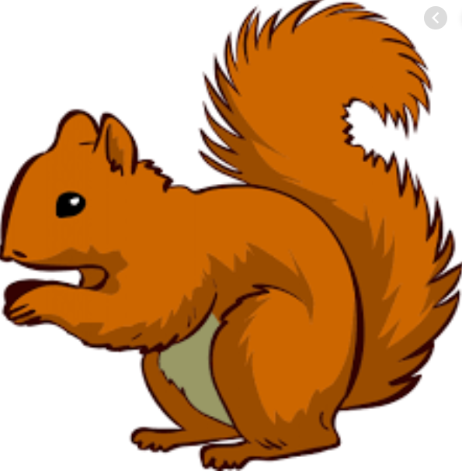
Welcome to Year 1
Squirrel Class Staff: Mrs Atkinson and Mrs Fillingham - Class Teachers
Mrs Draper and Mrs McDonald - Teaching Assistants
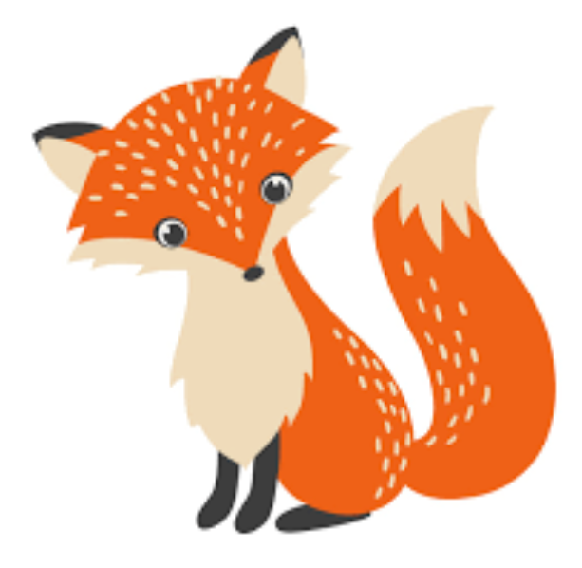
Fox Class Staff: Miss Clift – Class Teacher
Mrs Smith and Mrs Hurst – Teaching Assistants

Each week we will publish a bulletin that will give you information about: what the children are learning at school, ideas for how to help at home, reminders and notes and any dates for the diary.
We are available before and after school if you would like to chat to us. You can either catch us outside or see Mrs Sutton in the office who will make an appointment for you. We are really looking forward to working with you and your children this year.

Topic – I am amazing!

English – The Little Red Hen
For the next 3 weeks we will be learning the story off by heart and learning talk for writing actions to go with it. We will be doing lots of activities linked to the story, including making bread. You will receive a permission slip through parent mail this week so please look out for it.

Maths - Next week we will be recapping
* Counting forwards and backwards within 10
* Finding one more and one less
* Counting objects accurately
* Forming the numbers correctly.

Reading books:
We know you are all keen for the children to have reading books again and we are busy assessing and sorting out new books for the children to take home. As you can appreciate this will take some time so initially your child will come home with the reading colour they last had in Foundation. If you have any reading books or a reading record book at home please return them to school. Thank you!

Your child’s books will be changed once a week and they will be given two new books during the week to read over two days each. No additional books will be sent home but should you require anything further please look at the Oxford Owl website. Please ensure books bags are brought into school and reading records filled in for any reading done at home. Our aim is for a member of staff to listen to your child read twice a week.

Helping at home
* Please hear your child read at least 4 times a week and write in the reading record book.
* Read to your child – bedtime stories are the BEST!
* Practise counting sets of objects – ensuring they understand the numbers to 10 securely. Don’t be tempted to go too far.

Please Remember –
- At the moment children do not need to bring in a PE kit but they will need a bag of spare clothes to keep on their peg. We would appreciate it if this bag could include an art apron or old shirt as we cannot share aprons at present.
- Please make sure your child has a named water bottle in school.
- Please return any library books in their library folders.
- The fruit snack is currently not being provided by the NHS until Wednesday the 9th September, so please send your child in with a piece of fresh fruit or vegetables.

