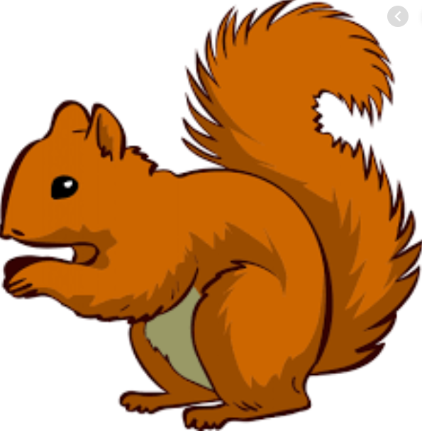
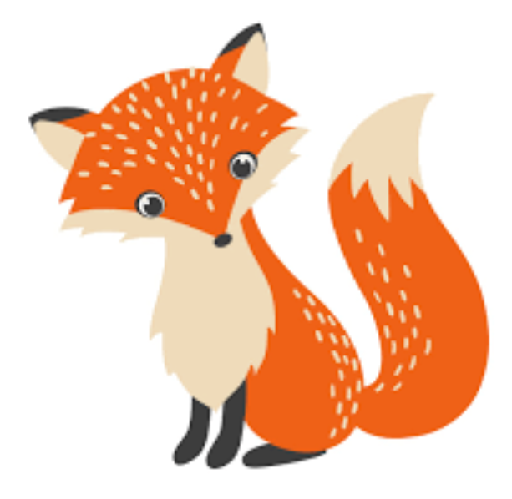
Week Beginning Monday 15th November 2021
Year 1 Bulletin
Squirrel Class Staff:
Mrs Atkinson and Mrs Fillingham - Class Teachers
Mrs Draper and Mrs McDonald - Teaching Assistants
Mrs Singh and Mrs Drummond - 1:1 Teaching Assistants
Support teacher- Mrs Leviss – Qualified Teacher, teaching across both classes

Fox Class Staff:
Miss Clift – Class Teacher
Mrs Smith and Mrs Hurst – Teaching Assistants
Mrs O’Reilly and Mrs Dobson – 1:1 Teaching Assistants
Mrs Morris and Mrs Redfern - 1:1 Teaching Assistants

.

Topic – Toys and special times!
Our trip to Reading museum was the perfect launch to our topic. This term we will be learning all about toys from the past and making our own. If possible, please can you send your child in with a photo of toys that are still in your family that are from the past. If you don’t have a printer, please email these photos to the office. We would love to share these with the children in History.
Dates for the diary
Year 1 teach in meeting - Tuesday 16th, 7pm
Children in need- Friday 19th November
Parents evening- 22nd, 23rd, 24th November

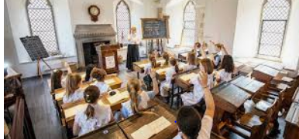
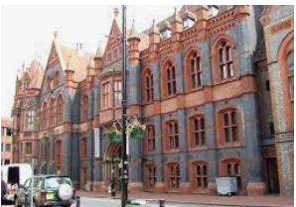
English – Recounts
This week we will use the experiences of Reading Museum to write a recount of their first ever school trip. We can’t wait to share this learning with them!
You could talk to your child about what they can remember from the trip. Use the language-
First…..Next we… Then we….. After that….. Finally

Maths – Shape
We will be naming 2D and 3D shapes, describing and sorting them.

Phonics
We have settled into our new phonics groups. Your child may now be on a new phonics level. Their new books may be more challenging but that is perfectly normal and they can use all their Emerald Power to be brave learners!

Reading
*Your child will read in a group with an adult each day. This will not be recorded in the reading diary. We will also listen to your child 1:1 each week and this will be recorded in the reading diary.
* Your child’s books will be changed once a week. They will be given 2 or 3 new books.
* One of the books they bring home will be a Read Write Inc book. This is the level they are working at and the sounds in these books will be covered in their phonics sessions.
* The other two books will be books to share at home. We do not expect your child to read these books independently – they are books that are sent home for you to enjoy together and to expand the children’s reading diet.
* Please ensure books bags are brought into school each day. Reading records should be filled in for any reading done at home - this should be done three times per week.
Helping at home
* Please hear your child read at least 3 times a week and write in the reading record book.
* Read to your child – bedtime stories are the BEST!
* Practise counting sets of objects – ensuring they understand the numbers to 10 securely. Don’t be tempted to go too far.

The children in year 1 now all have logins for purple mash. Please log into your child’s account and have an explore of the games and activities available to use. You will find their log in details in their reading record book.
https://2simple.com/purple-mash/

Library day will be on a Wednesday for Squirrels and a Thursday for Foxes. If your child would like to change their book please ensure they bring their library folder and book to school on their library day.
Please Remember –
- Children come in PE kit on Tuesdays.
- They will need a bag of spare clothes to keep on their peg.
- Please make sure your child has a named water bottle in school.
- Please return any library books in their library folders.

Many thanks for your support, The Year 1 Team

