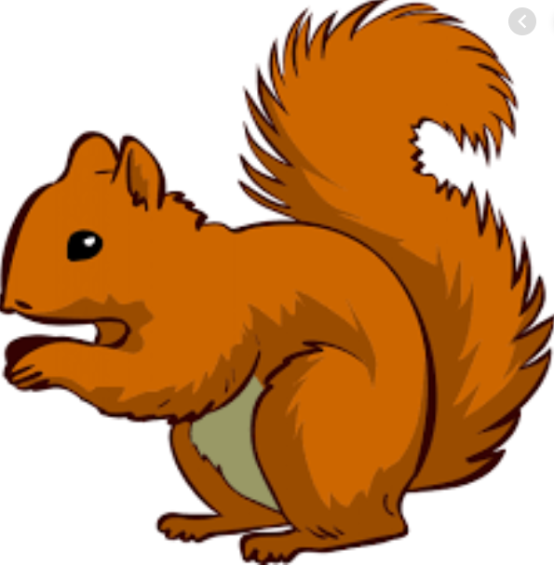
Week Beginning Monday 02nd May 2022
Year 1 Bulletin
Squirrel Class Staff:
Mrs Atkinson - Class Teacher
Mrs Draper and Mrs McDonald - Teaching Assistants
Mrs Singh and Mrs Drummond - 1:1 Teaching Assistants
Support teacher- Mrs Leviss – Qualified Teacher, teaching across both classes

Fox Class Staff:
Miss Clift – Class Teacher
Mrs Smith and Mrs Hurst – Teaching Assistants
Mrs O’Reilly and Mrs Dobson – 1:1 Teaching Assistants
Mrs Morris and Mrs Redfern - 1:1 Teaching Assistants
S
.

Dates for the Diary-

English
In English we will be learning the script for Scruff and Felix’s travel guide. This will prepare us for writing our own travel guide.
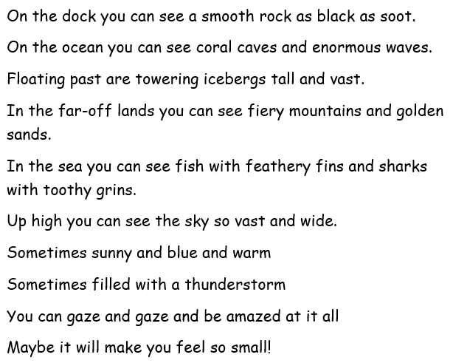
We will be learning how to use descriptive language to write a non-fiction text. Here is a copy of the script if you would like to practise. The children have been learning actions to retell it.

In Maths this week we will be
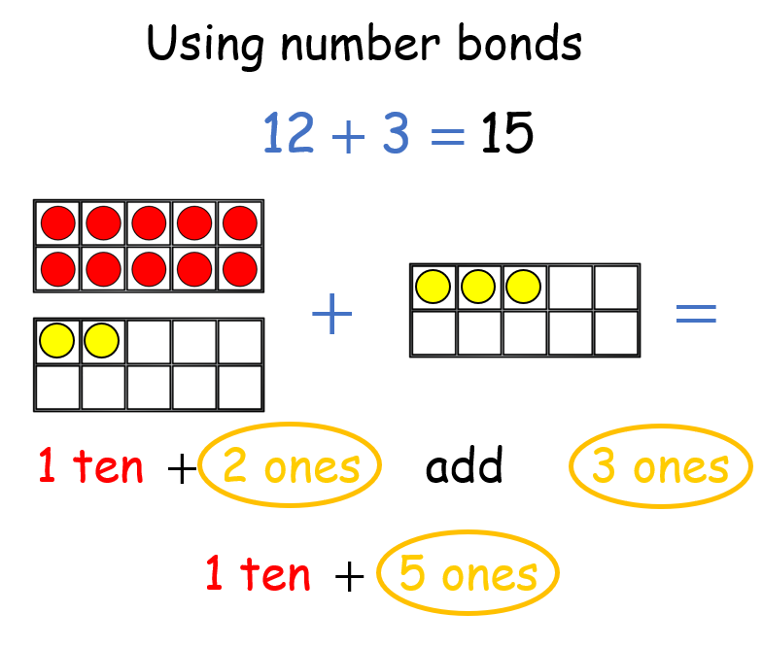
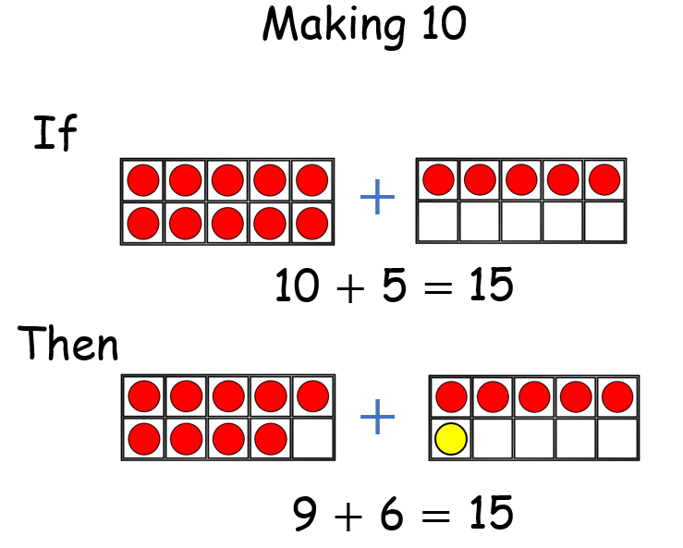
-Using Number bonds
-Subtraction by crossing 10
-Adding by making 10

Ask your child to tell you our number
Bond song.

Reading –

*Your child will read in a group with an adult each day. This will not be recorded in the reading diary. We will also listen to your child 1:1 each week and this will be recorded in the reading diary.
* Your child’s books will be changed once a week. They will be given 2 or 3 new books.
* One of the books they bring home will be a Read Write Inc book. This is the level they are working at and the sounds in these books will be covered in their phonics sessions.
* The other two books will be books to share at home. We do not expect your child to read these books independently – they are books that are sent home for you to enjoy together and to expand the children’s reading diet.
* Please ensure books bags are brought into school each day. Reading records should be filled in for any reading done at home - this should be done three times per week.
Helping at home
* Please hear your child read at least 3 times a week and write in the reading record book.
* Read to your child – bedtime stories are the BEST!
* Practise counting sets of objects – ensuring they understand the numbers to 10 securely. Don’t be tempted to go too far. 7

The children in year 1 now all have logins for purple mash. Please log into your child’s account and have an explore of the games and activities available to use. You will find their log in details in their reading record book.
https://2simple.com/purple-mash/
Please Remember –
- Children come in PE kit on Tuesdays and Thursdays.
- They will need a bag of spare clothes to keep on their peg.
- Please make sure your child has a named water bottle in school.
- Please return any library books in their library folders.

Many thanks for your support, The Year 1 Team

