Week Beginning Monday 18th October 2021
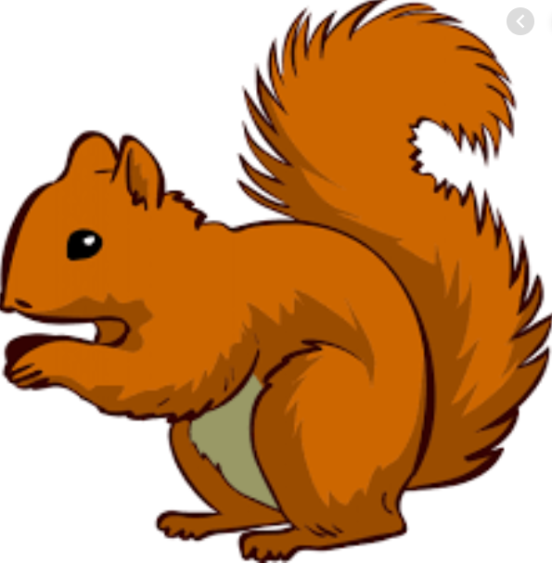
Year 1 Bulletin
Squirrel Class Staff: Mrs Atkinson and Mrs Fillingham - Class Teachers
Mrs Draper and Mrs McDonald - Teaching Assistants
Mrs Singh and Mrs Drummond - 1:1 Teaching Assistants
Fox Class Staff: Miss Clift – Class Teacher
Mrs Smith and Mrs Hurst – Teaching Assistants
Mrs O’Reilly and Mrs Dobson – 1:1 Teaching Assistants
Mrs Morris and Mrs Redfern - 1:1 Teaching Assistants
Support teacher- Mrs Leviss – Qualified Teacher, teaching across both classes.
Each week we will publish a bulletin that will give you information about what the children are learning at school, ideas for how to help at home, reminders and notes and any dates for the diary.
We are available before and after school if you would like to chat to us. You can either catch us outside or see Mrs Vallance or Mrs Lambert in the office who will make an appointment for you. Your children are working so hard and we are really proud of them.

Topic – I am amazing!
Tuesday afternoon will now be Celebration Assembly. This is an opportunity for your child to show or talk about any achievements or certificates/awards. If your child attends a club and has anything they would like to celebrate please send it in their book bag on a Tuesday morning.
Library day will be on a Wednesday for Squirrels and a Thursday for Foxes. If your child would like to change their book please ensure they bring their library folder and book to school on their library day.
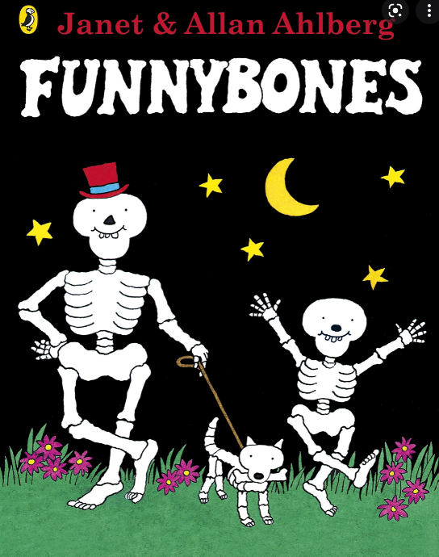
English – “Funny Bones”
For the last two weeks we will be reading the story Funny Bones. We will be using the story to help us write sentences using adjectives to describe and using “and” to join ideas. You could help your child think of adjectives to describe their toys. “Smooth car” “Soft teddy” “bendy poppet” “hard lego”.
Maths – Number bonds
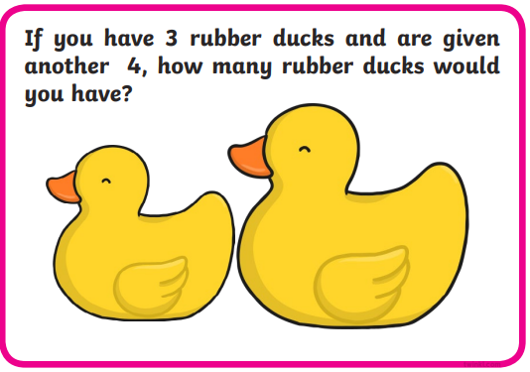
In maths this week we will be learning about-
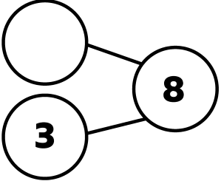
-Adding together, you could have a go at this word problem
-Adding more
-Finding a missing part, how many more do you need to make 8?

Reading
Reading Assessment-
The next reading assessment will take place in a couple of weeks’ time. Your child may change reading colour and phonics group for next term. If they do not move, please don’t worry.
Other key information about reading:
* Your child will read in a group with an adult each day. This will not be recorded in the reading diary. We will also listen to your child 1:1 each week and this will be recorded in the reading diary.
* Your child’s books will be changed once a week. They will be given 2 or 3 new books.
* One of the books they bring home will be a Read Write Inc book. This is the level they are working at and the sounds in these books will be covered in their phonics sessions.
* The other two books will be books to share at home. We do not expect your child to read these books independently – they are books that are sent home for you to enjoy together and to expand the children’s reading diet.
* Please ensure books bags are brought into school each day. Reading records should be filled in for any reading done at home - this should be done three times per week.

Helping at home
* Please hear your child read at least 3 times a week and write in the reading record book.
* Read to your child – bedtime stories are the BEST!
* Practise counting sets of objects – ensuring they understand the numbers to 10 securely. Don’t be tempted to go too far.
Please Remember –
- Children come in PE kit on Tuesdays.
- They will need a bag of spare clothes to keep on their peg.
- Please make sure your child has a named water bottle in school.
- Please return any library books in their library folders.

PTA Christmas cards

You will find your child’s Christmas card in their book bag. If you would like their image printed on christas cards please follow the instructions and order these online.

Please ensure that you let a year 1 member of staff know in the morning if someone different is going to pick your child up from school.

Many thanks for your support, The Year 1 Team

