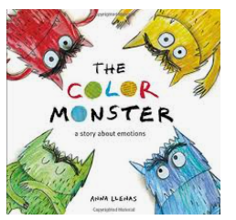
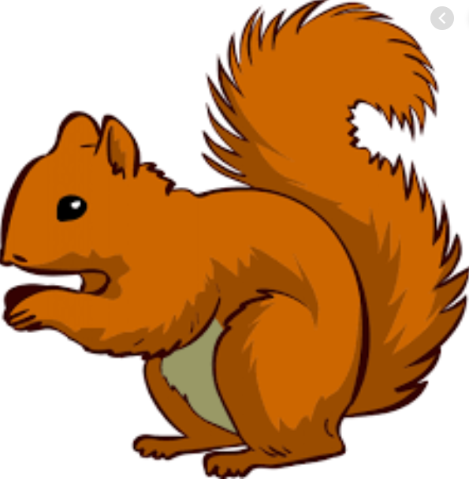
Week Beginning Monday 19th September 2020
Topic – I am amazing!
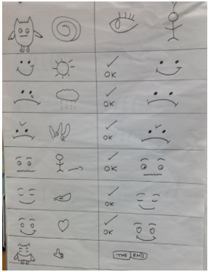
English – The Colour Monster
We have created our own versions of the poem map this week. Next week we will be writing our own poem and reading them out in class.
Maths – Using mathematical skills
* Ordinal numbers (1st,2nd,3rd)
*Using greater than, less than and equal to signs
*Number formation (making sure the numbers are round the right way)
*Fact families

Next week in maths we will be consolidating key skills-

Maths
The children have loved practising skip counting in 2s, 5s and 10s. Counting and writing digits 0-20 is very important and can be practised in lots of different ways.
To help them at home, you could play games and get them to write the scores; they could count out pennies to pay for things. You could go on an autumn walk and count the number of steps they take, you could also point out and recognise door numbers.

PSHE
This week’s focus is using “Emerald” power (perseverance, not giving up). Please have a chat with your children about what it means to show perseverance and talk about even when it gets hard to not give up. There is no such thing as can’t... “you can’t do it yet” .

Other ways to help at home
* Read to your child – bedtime stories are the BEST!
* Ask your child questions like “What was your favourite part of the story?” “Who was your favourite character?” for non fiction “Why do you think the book has this title?” “What do you think it will be about?” “What information does it give us?”
Key question- How many ways can we write addition to 10? (1 + 9 = 10, 9+1 = 10, 2 + 8 = 10, 8+2= 10…)
Donations
We would be really grateful for any of the following donations. We have already had some in and the children have loved using them all!
*Cotton Buds *Golf tees *Rice *Dry noodles *Flour *Oats *Lentils *Junk modelling
These will greatly enhance our provision for the children. Many thanks in advance.
Many thanks Miss Clift, Mrs Atkinson and Mrs Fillingham

