11th – 15th January 2021
Year Two Class Bulletin

Hello and well done for completing another week of home learning. We hope that it is becoming slightly easier to juggle everything and you are establishing a routine that works for you.

It is lovely to see the children on the drop ins in the morning and have a catch up. These are every week day at 9am for the boys and 11am for the girls.

Thank you for all the work you have been doing and sending in. It is great to see what you have been up to. If there is no set assignment for a subject and you would like to send work in, please feel free to email it to us or attach it to another assignment on Teams.

English

Next week we will be continuing to learn our Gorilla story, using the script and actions. We will be practising writing speech bubbles and using direct speech.

Maths

Next week in maths we will be looking at division. We will be doing this by:
- Equal groups – Sharing
- Equal groups – Grouping
- Dividing by 2

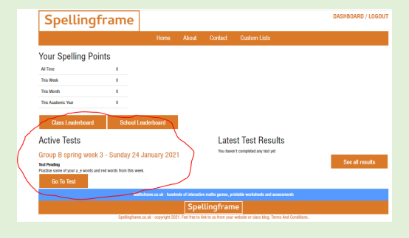
Spelling Frame

You should have all received an email with your child’s login details for spellingframe.co.uk
This will allow you to log on and practise spelling high frequency words and words with a specific sound. There are practise and test options as well as spelling games for the children to use. Each week in phonics you will be given a particular list of words to practise and this will show up on the ‘dashboard’ under ‘Active Tests’.

Queries about work can be emailed to us on:
hlewis@willowbank-inf.wokingham.sch.uk (Monday- Thursday)
lturner@willowbank-inf.wokingham.sch.uk (Monday, Tuesday and Friday)
sdavies@willowbank-inf.wokingham.sch.uk (Wednesday, Thursday, Friday)
We will endeavour to answer all emails sent during school hours the same day, otherwise they will be answered the next working day. Feed back will be given twice a week for maths and English and we will have daily drop in sessions.

You should all still have logins for Purple Mash and Education City which have lots of games and activities that compliment what the children are learning. If you sign up to Oxford Owl you can access lots of books online. We have added some other websites that might be useful for additional activities.
https://go.educationcity.com/?_ga=2.244359744.496286403.1609857965-881931223.1609857965

https://www.purplemash.com/sch/wbinfant

https://www.oxfordowl.co.uk/please-log-in

https://www.bbc.co.uk/bitesize/levels/z3g4d2p BBC bitesize have lots of additional lessons that you can access to compliment what the children are doing in their home learning.

https://www.phonicsplay.co.uk/ Phonics play have set up a new free login for parents to access at home.
Username: jan21
Password: home

https://www.ictgames.com/ On this website there is a selection of Literacy and Maths games.

