20/02/17  People who help us at school and home. | - Communication and language: Sharing holiday news  - Literacy: List of people who help us at school and home why.  - Maths : Patterns and Ordering numbers to 20.  - Understanding of the world: What jobs do people do?  - Expressive Design: Role play (school). Split pins characters. Look at patterns in our environment and creating patterns using natural objects.  - Physical Development: Gymnastics  - Personal, Social, Emotional Development: Being kind and helpful to others. How do you help others at school and at home?
27/02/17  People who help us when we are sick  02/3/17- World Book day | - Communication and language: Visit by a Paramedic. What’s your favourite story and why?  - Literacy: Letters (invitation and thank you letters) Book reviews.  - Maths: Capacity and Time  - Understanding of the world: Traditions: Pancake Tuesday and making pancakes.  - Expressive Design: Role play (Doctors surgery)  - Physical Development: Gymnastics  - Personal, Social, Emotional Development: What happens when we are sick? How can we keep healthy?
06/3/17  People who keep us safe | - Communication and language: Firefighters and police officers  - Literacy: Burglar Bill (Story map) wanted posters  - Maths: Number bonds to 10  Understanding of the world: reflective materials – sometimes worn by people who help us. Encourage children to explore the materials using torches and mirrors.  - Expressive Design: Police station in the outdoor area. Make a fire engine using large boxes and bricks  - Physical Development: Gymnastics  - Personal, Social, Emotional Development: How can we keep safe? Who helps us to keep safe?
13/3/17  Signs of spring | - Communication and language: Spring walk- Retelling ‘Jaspers Beanstalk’ look for signs of spring  - Literacy: Text: Mouse’s First Spring. Springtime Poem – In the Springtime  - Maths: Length and Sharing  - Understanding of the world: Growth –Growing plants Text :Jaspers Beanstalk  - Expressive Design: Observational drawings of spring flowers.  - Physical Development: Gymnastics  - Personal, Social, Emotional Development: Growth mindset- trying our best
20/3/17  New life  26/3/17 Mother’s day | - Communication and language:  - Literacy: Share Text: My Mum by Anthony Brown and the children talk about why their mums are special. Writing: My mum is ……  - Maths : Doubles  - Understanding of the world: Traditions Mother’s Day and Easter  - Expressive Design: Making Mother’s Day Card  - Physical Development: Gymnastics  - Personal, Social, Emotional Development: Circle time about our mums.
27/03/17  Easter | - Communication and language: Retelling the Easter story  - Literacy: Sequencing the Easter story.  - Maths : Sharing  - Understanding of the world: How is Easter celebrated and why?  - Expressive Design: Making Easter cards  - Physical Development: Gymnastics  - Personal, Social, Emotional Development: What am I good at?
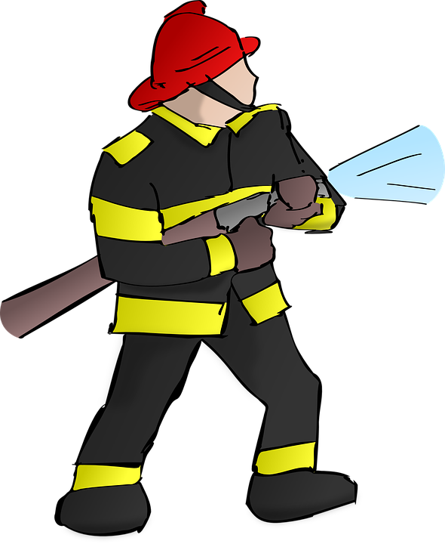Superheroes/Spring